## Streams & Lambda (Kinesis & DynamoDB)

* An event source mapping creates an iterator for each shard, processes items in order
* Start with new items, from the beginning or from timestamp
* Processed items aren't removed from the stream (other consumers can read them)
* Low traffic: use batch window to accumulate records before processing
* You can process multiple batches in parallel
  + up to 10 batches per shard
  + in-order processing is still guaranteed for each partition key,

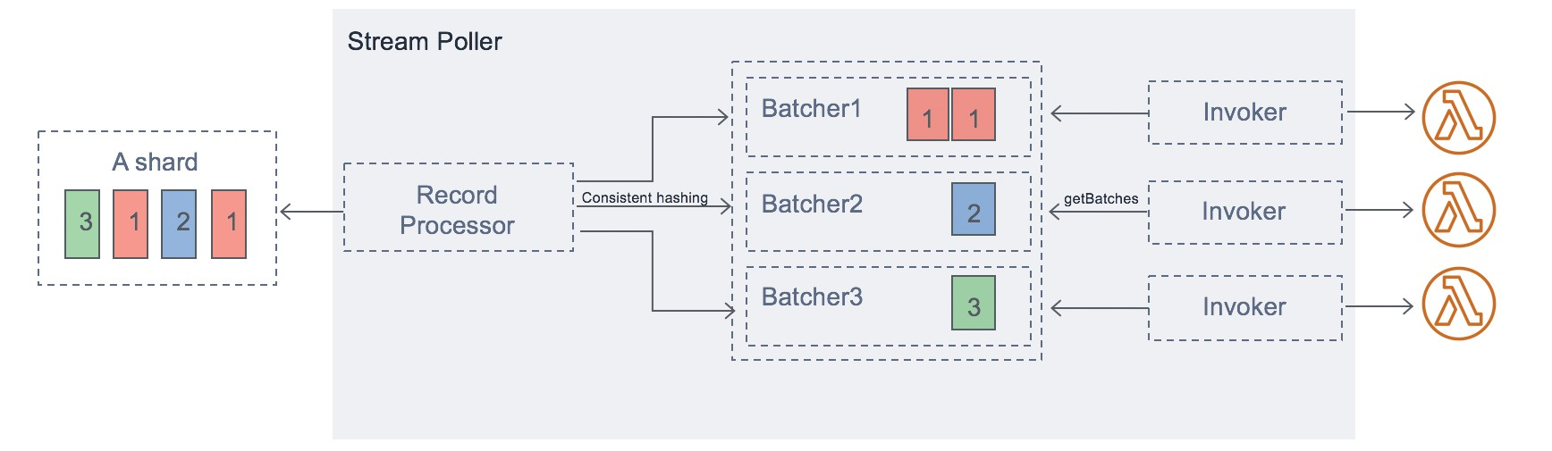

## Streams & Lambda – Error Handling

* By default, if your function returns an error, the entire batch is reprocessed until the function succeeds, or the items in the batch expire.
* To ensure in-order processing, processing for the affected shard is paused until the error is resolved
* You can configure the event source mapping to:
  + discard old events
  + restrict the number of retries
  + split the batch on error (to work around Lambda timeout issues)
* Discarded events can go to a Destination

## Lambda – Event Source Mapping SQS & SQS FIFO

* Event Source Mapping will poll SQS (Long Polling)
* Specify batch size (1-10 messages)

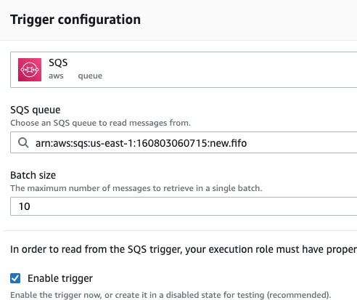

* Recommended: Set the queue visibility timeout to 6x the timeout of your Lambda function

###### To use a DLQ

* + set-up on the SQS queue, not Lambda (DLQ for Lambda is only for async invocations)
  + Or use a Lambda destination for failures

SQS

POLL RETURN BATCH



Lambda

Event Source Mapping

INVOKE WITH EVENT BATCH

Lambda Function

## Queues & Lambda

* Lambda also supports in-order processing for FIFO (first-in, first-out) queues,

scaling up to the number of active message groups.

* For standard queues, items aren't necessarily processed in order.
* Lambda scales up to process a standard queue as quickly as possible.
* When an error occurs, batches are returned to the queue as individual items and might be processed in a different grouping than the original batch.
* Occasionally, the event source mapping might receive the same item from the queue twice, even if no function error occurred.
* Lambda deletes items from the queue after they're processed successfully.
* You can configure the source queue to send items to a dead-letter queue if they can't be processed.

## Lambda Event Mapper Scaling

#### Kinesis Data Streams & DynamoDB Streams:

* + One Lambda invocation per stream shard
  + If you use parallelization, up to 10 batches processed per shard simultaneously

#### SQS Standard:

* + Lambda adds 60 more instances per minute to scale up
  + Up to 1000 batches of messages processed simultaneously

#### SQS FIFO:

* + Messages with the same GroupID will be processed in order
  + The Lambda function scales to the number of active message groups

## Lambda – Destinations

* Nov 2019: Can configure to send result to a

destination

* Asynchronous invocations - can define destinations for successful and failed event:
  + Amazon SQS
  + Amazon SNS
  + AWS Lambda
  + Amazon EventBridge bus
* 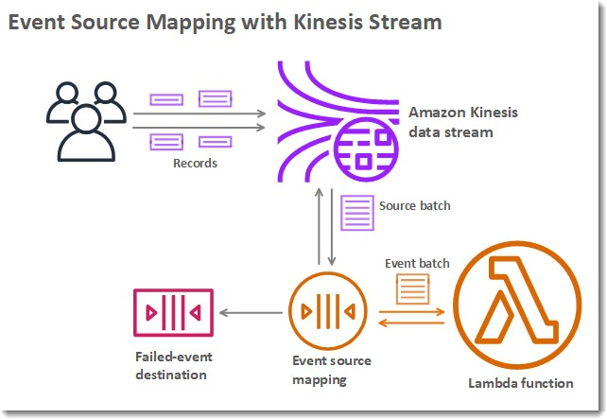*Note: AWS recommends you use destinations instead of DLQ now (but both can be used at the same time)*
* Event Source mapping: for discarded event batches
  + Amazon SQS
  + Amazon SNS
* *Note: you can send events to a DLQ directly from SQS*

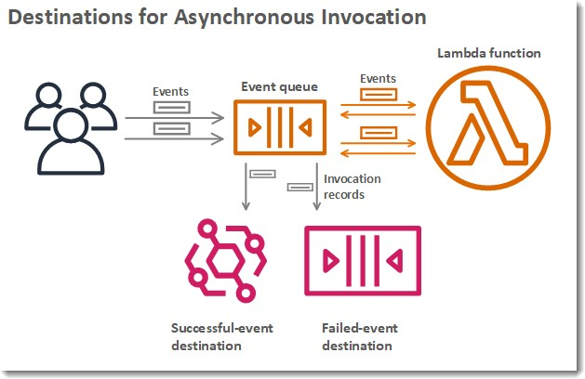

https://docs.aws.amazon.com/lambda/latest/dg/invocation-async.html

## Lambda Execution Role (IAM Role)

* Grants the Lambda function permissions to AWS services / resources
* Sample managed policies for Lambda:
  + AWSLambdaBasicExecutionRole – Upload logs to CloudWatch.
  + AWSLambdaKinesisExecutionRole – Read from Kinesis
  + AWSLambdaDynamoDBExecutionRole – Read from DynamoDB Streams
  + AWSLambdaSQSQueueExecutionRole – Read from SQS
  + AWSLambdaVPCAccessExecutionRole – Deploy Lambda function in VPC
  + AWSXRayDaemonWriteAccess – Upload trace data to X-Ray.
* When you use an event source mapping to invoke your function, Lambda uses the execution role to read event data.
* Best practice: create one Lambda Execution Role per function

## Lambda Resource Based Policies

* Use resource-based policies to give other accounts and AWS services permission to use your Lambda resources
* Similar to S3 bucket policies for S3 bucket
* An IAM principal can access Lambda:
  + if the IAM policy attached to the principal authorizes it (e.g. user access)
  + OR if the resource-based policy authorizes (e.g. service access)
* When an AWS service like Amazon S3 calls your Lambda function, the resource-based policy gives it access.

## Lambda Environment Variables

* Environment variable = key / value pair in “String” form
* Adjust the function behavior without updating code
* The environment variables are available to your code
* Lambda Service adds its own system environment variables as well
* Helpful to store secrets (encrypted by KMS)
* Secrets can be encrypted by the Lambda service key, or your own CMK

## Lambda Logging & Monitoring

* CloudWatch Logs:
  + AWS Lambda execution logs are stored in AWS CloudWatch Logs
  + Make sure your AWS Lambda function has an execution role with an IAM policy that authorizes writes to CloudWatch Logs
* CloudWatch Metrics:
  + AWS Lambda metrics are displayed in AWS CloudWatch Metrics
  + Invocations, Durations, Concurrent Executions
  + Error count, Success Rates,Throttles
  + Async Delivery Failures
  + Iterator Age (Kinesis & DynamoDB Streams)

## Lambda Tracing with X-Ray

* Enable in Lambda configuration (Active Tracing)
* Runs the X-Ray daemon for you
* Use AWS X-Ray SDK in Code
* Ensure Lambda Function has a correct IAM Execution Role
  + The managed policy is called AWSXRayDaemonWriteAccess
* Environment variables to communicate with X-Ray
  + _X_AMZN_TRACE_ID: contains the tracing header
  + AWS_XRAY_CONTEXT_MISSING: by default, LOG_ERROR
  + AWS_XRAY_DAEMON_ADDRESS: the X-Ray Daemon IP_ADDRESS:PORT

## Lambda by default

* By default, your Lambda function is launched outside your own VPC (in an AWS-owned VPC)



AWS Cloud

Public www works

DynamoDB

VPC & Private Subnet

Not working

Private RDS

* Therefore it cannot access resources in your VPC (RDS, ElastiCache, internal ELB…)

Default Lambda Deployment

## Lambda in VPC

* + You must define the VPC ID, the Subnets and the Security Groups



* + Lambda will create an ENI (Elastic Network Interface) in your subnets

#### AWSLambdaVPCAccessExecutionRole



Lambda Function

**Private subnet**

Lambda Security group



Elastic Network Interface (ENI)



RDS Security group

Amazon RDS In VPC

## Lambda in VPC – Internet Access



External API

* + A Lambda function in your VPC does not have internet access

###### Deploying a Lambda function in a public subnet does not give it internet access or a public IP

* + Deploying a Lambda function in a private subnet gives it internet access if you have a NAT Gateway / Instance
  + You can use VPC endpoints to privately access AWS services without a NAT

Lambda in VPC

AWS Cloud

Public subnet

NAT IGW

working Assign security group

DynamoDB

Endpoint

VPC & Private Subnet

Private RDS

Note: Lambda - CloudWatch Logs works even without endpoint or NAT Gateway

## Lambda Function Configuration

#### RAM:

* + - From 128MB to 10GB in 1MB increments
    - The more RAM you add, the more vCPU credits you get
    - At 1,792 MB, a function has the equivalent of one full vCPU
    - After 1,792 MB, you get more than one CPU, and need to use multi-threading in your code to benefit from it (up to 6 vCPU)
  + If your application is CPU-bound (computation heavy), increase RAM
  + Timeout: default 3 seconds, maximum is 900 seconds (15 minutes)

## Lambda Execution Context

* + The execution context is a temporary runtime environment that initializes any external dependencies of your lambda code
  + Great for database connections, HTTP clients, SDK clients…
  + The execution context is maintained for some time in anticipation of another Lambda function invocation
  + The next function invocation can “re-use” the context to execution time and save time in initializing connections objects
  + The execution context includes the */tmp* directory

## Initialize outside the handler

**BAD!**

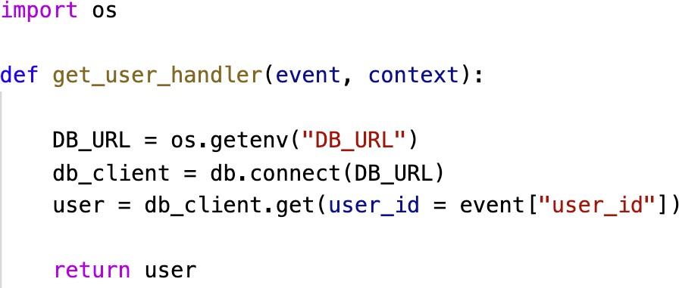

The DB connection is established At every function invocation

**GOOD!**

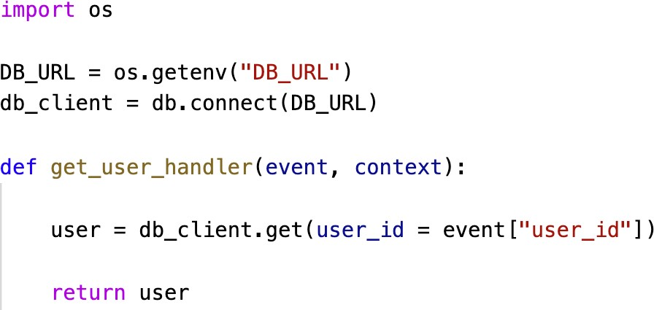

The DB connection is established once And re-used across invocations

## Lambda Functions /tmp space

* + If your Lambda function needs to download a big file to work…
  + If your Lambda function needs disk space to perform operations…
  + You can use the /tmp directory
  + Max size is 10GB
  + The directory content remains when the execution context is frozen, providing transient cache that can be used for multiple invocations (helpful to checkpoint your work)
  + For permanent persistence of object (non temporary), use S3

## Lambda Concurrency and Throttling

* + Concurrency limit: up to 1000 concurrent executions
  + Can set a “reserved concurrency” at the function level (=limit)
  + Each invocation over the concurrency limit will trigger a “Throttle”
  + Throttle behavior:
    - If synchronous invocation => return ThrottleError - 429
    - If asynchronous invocation => retry automatically and then go to DLQ
  + If you need a higher limit, open a support ticket

## Lambda Concurrency Issue

* + If you don’t reserve (=limit) concurrency, the following can happen:

      

Many users

Few users



SDK / CLI

Application Load Balancer

THROTTLE!

API Gateway

THROTTLE!

1000 concurrent executions

      





## Concurrency and Asynchronous Invocations

* + - If the function doesn't have enough concurrency available to process all events, additional requests are throttled.



New file event

New file event

S3 bucket

New file event

* + - For throttling errors (429) and system errors (500-series), Lambda returns the event to the queue and attempts to run the function again for up to 6 hours.
    - The retry interval increases exponentially from 1 second after the first attempt to a maximum of 5 minutes.

## Cold Starts & Provisioned Concurrency

##### Cold Start:

* + - New instance => code is loaded and code outside the handler run (init)
    - If the init is large (code, dependencies, SDK…) this process can take some time.
    - First request served by new instances has higher latency than the rest

##### Provisioned Concurrency:

* + - Concurrency is allocated before the function is invoked (in advance)
    - So the cold start never happens and all invocations have low latency
    - Application Auto Scaling can manage concurrency (schedule or target utilization)

##### Note:

* + - Note: cold starts in VPC have been dramatically reduced in Oct & Nov 2019

## Reserved and Provisioned Concurrency

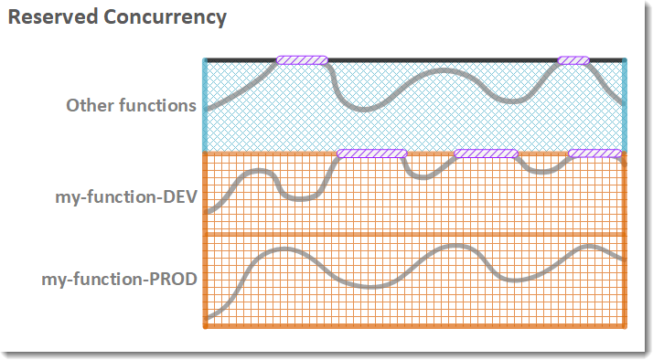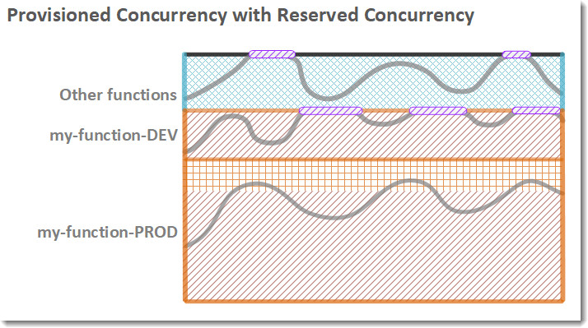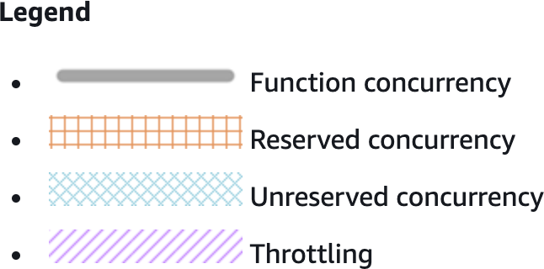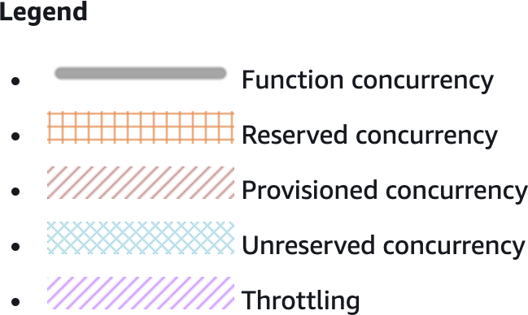

Lambda Function Dependencies

* + If your Lambda function depends on external libraries: for example AWS X-Ray SDK, Database Clients, etc…
  + You need to install the packages alongside your code and zip it together
    - For Node.js, use npm & “node_modules” directory
    - For Python, use pip --target options
    - For Java, include the relevant .jar files
  + Upload the zip straight to Lambda if less than 50MB, else to S3 first
  + Native libraries work: they need to be compiled on Amazon Linux
  + AWS SDK comes by default with every Lambda function

## Lambda and CloudFormation – inline

* + - Inline functions are very simple

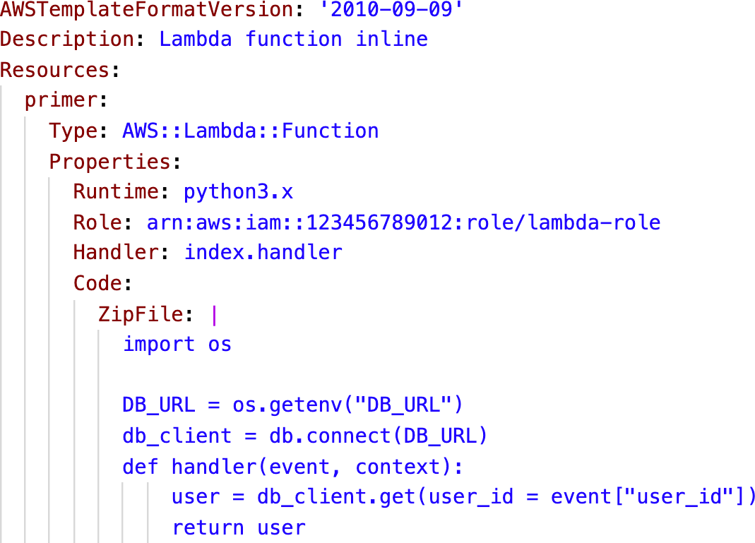

* + - Use the Code.ZipFile

property

* + - You cannot include function dependencies with inline functions

## Lambda and CloudFormation – through S3

* You must store the Lambda zip in S3

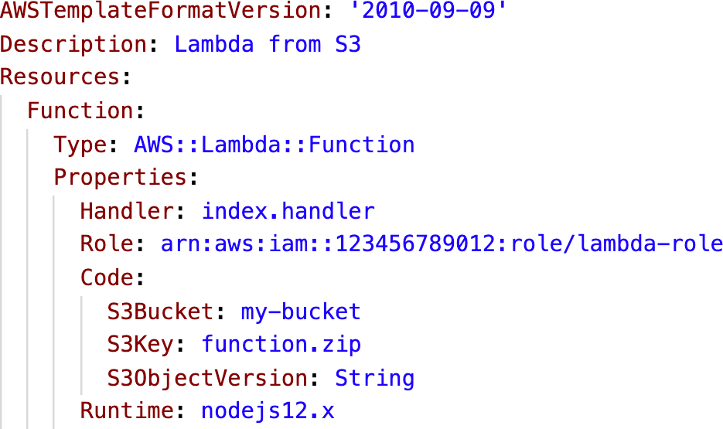

* You must refer the S3 zip location in the CloudFormation code
  + S3Bucket
  + S3Key: full path to zip
  + S3ObjectVersion: if versioned bucket
* If you update the code in S3, but don’t update S3Bucket, S3Key or S3ObjectVersion, CloudFormation won’t update your function

## Lambda and CloudFormation – through S3 Multiple accounts



Account 1



Account 2

CloudFormation Execution Role

S3 bucket with Lambda Code



Allow get & list To S3 bucket



Bucket policy

Allow Principal: [Accounts ID…]

Account 3



CloudFormation



Execution Role

## Lambda Layers

* + Custom Runtimes
    - Ex: C++ https://github.com/awslabs/aws-lambda-cpp
    - Ex: Rust https://github.com/awslabs/aws-lambda-rust-runtime
  + Externalize Dependencies to re-use them:

Application Package 1 (30.02MB)

Application Package 1 (20KB)

Application Package 1 (60KB)

lambda_function_1.py

+

my_heavy_library_1 files

+

my_heavy_library_2 files

**Lambda Layer 2 (30 MB)**

my_heavy_library_2 files

**Lambda Layer 1 (10 MB)**

my_heavy_library_1 files

lambda_function_2.py

lambda_function_1.py

## Lambda Container Images

|  |  |
| --- | --- |
|  | Application Code |
| Dependencies, datasets |
| Base Image must implement the  **Lambda Runtime API** | |

* + Deploy Lambda function as container images of up to 10GB from ECR
  + Pack complex dependencies, large dependencies in a container
  + Base images are available for Python, Node.js, Java, .NET, Go, Ruby
  + Can create your own image as long as it implements the Lambda Runtime API
  + Test the containers locally using the Lambda Runtime Interface Emulator
  + Unified workflow to build apps

Build Publish



Amazon ECR

Deploy



Lambda

## Lambda Container Images

* + Example: build from the base images provided by AWS

# Use an image that implements the Lambda Runtime API FROM amazon/aws-lambda-nodejs:12

# Copy your applciation code and files COPY app.js package*.json ./

# Install the dependencies in the container RUN npm install

# Function to run when the Lambda function is invoked CMD [ "app.lambdaHandler" ]

## AWS Lambda Versions

* + When you work on a Lambda function, we work on $LATEST

V2

(Immutable)

V1

(Immutable)

$LATEST

(mutable)

* + When we’re ready to publish a Lambda function, we create a version
  + Versions are immutable
  + Versions have increasing version numbers
  + Versions get their own ARN (Amazon Resource Name)
  + Version = code + configuration (nothing can be changed - immutable)
  + Each version of the lambda function can be accessed

## AWS Lambda Aliases

5%

V2

(Immutable)

V1

(Immutable)

* + Aliases are ”pointers” to Lambda function versions
  + We can define a “dev”, ”test”, “prod” aliases and have them point at different lambda versions
  + Aliases are mutable
  + Aliases enable Blue / Green deployment by assigning weights to lambda functions
  + Aliases enable stable configuration of our event triggers / destinations
  + Aliases have their own ARNs

##### Aliases cannot reference aliases

TEST Alias (mutable)

PROD Alias (mutable)

Users

95%

DEV Alias (mutable)

$LATEST

(mutable)

## Lambda & CodeDeploy

* + CodeDeploy can help you automate traffic shift for Lambda aliases
  + Feature is integrated within the SAM framework
  + Linear: grow traffic every N minutes until 100%
    - Linear10PercentEvery3Minutes
    - Linear10PercentEvery10Minutes
  + Canary: try X percent then 100%
    - Canary10Percent5Minutes
    - Canary10Percent30Minutes
  + AllAtOnce: immediate
  + Can create Pre & Post Traffic hooks to check the health of the Lambda function

Make X vary over time until X = 100%

V1



PROD Alias

100 – X%

CodeDeploy

X%

V2

AWS Lambda Limits to Know - per region

* + Execution:
    - Memory allocation: 128 MB – 10GB (1 MB increments)
    - Maximum execution time: 900 seconds (15 minutes)
    - Environment variables (4 KB)
    - Disk capacity in the “function container” (in /tmp): 512 MB to 10GB
    - Concurrency executions: 1000 (can be increased)

#### Deployment:

* + - Lambda function deployment size (compressed .zip): 50 MB
    - Size of uncompressed deployment (code + dependencies): 250 MB
    - Can use the /tmp directory to load other files at startup
    - Size of environment variables: 4 KB

## AWS Lambda Best Practices

##### Perform heavy-duty work outside of your function handler

* + - Connect to databases outside of your function handler
    - Initialize the AWS SDK outside of your function handler
    - Pull in dependencies or datasets outside of your function handler

##### Use environment variables for:

* + - Database Connection Strings, S3 bucket, etc… don’t put these values in your code
    - Passwords, sensitive values… they can be encrypted using KMS

##### Minimize your deployment package size to its runtime necessities.

* + - Break down the function if need be
    - Remember the AWS Lambda limits
    - Use Layers where necessary

##### Avoid using recursive code, never have a Lambda function call itself

©

DynamoDB

NoSQL Serverless Database

## Traditional Architecture



Auto Scaling group

EC2 Instance

EC2 Instance

Application Layer

Clients

Elastic Load Balancer



Database Layer

Amazon RDS

(MySQL, PostgreSQL, …)

* + Traditional applications leverage RDBMS databases
  + These databases have the SQL query language
  + Strong requirements about how the data should be modeled
  + Ability to do query joins, aggregations, complex computations
  + Vertical scaling (getting a more powerful CPU / RAM / IO)
  + Horizontal scaling (increasing reading capability by adding EC2 / RDS Read Replicas)

## NoSQL databases

* + NoSQL databases are non-relational databases and are distributed
  + NoSQL databases include MongoDB, DynamoDB, …
  + NoSQL databases do not support query joins (or just limited support)
  + All the data that is needed for a query is present in one row
  + NoSQL databases don’t perform aggregations such as “SUM”, “AVG”, …
  + NoSQL databases scale horizontally
  + There’s no “right or wrong” for NoSQL vs SQL, they just require to model the data differently and think about user queries differently

## Amazon DynamoDB

* + Fully managed, highly available with replication across multiple AZs
  + NoSQL database - not a relational database
  + Scales to massive workloads, distributed database
  + Millions of requests per seconds, trillions of row, 100s of TB of storage
  + Fast and consistent in performance (low latency on retrieval)
  + Integrated with IAM for security, authorization and administration
  + Enables event driven programming with DynamoDB Streams
  + Low cost and auto-scaling capabilities
  + Standard & Infrequent Access (IA) Table Class

## DynamoDB - Basics

* + DynamoDB is made of Tables
  + Each table has a Primary Key (must be decided at creation time)
  + Each table can have an infinite number of items (= rows)
  + Each item has attributes (can be added over time – can be null)
  + Maximum size of an item is 400KB
  + Data types supported are:
    - Scalar Types – String, Number, Binary, Boolean, Null
    - Document Types – List, Map
    - Set Types – String Set, Number Set, Binary Set

## DynamoDB – Primary Keys

#### Option 1: Partition Key (HASH)

* + - Partition key must be unique for each item
    - Partition key must be “diverse” so that the data is distributed
    - Example: “User_ID” for a users table

Primary Key

Partition Key

Attributes

User_ID

First_Name

Last_Name

Age

7791a3d6-…

John

William

46

873e0634-…

Oliver

24

a80f73a1-…

Katie

Lucas

31

## DynamoDB – Primary Keys

##### Option 2: Partition Key + Sort Key (HASH + RANGE)

* + - The combination must be unique for each item
    - Data is grouped by partition key
    - Example: users-games table, “User_ID” for Partition Key and “Game_ID” for Sort Key

**Primary Key** Attributes

Same partition key Different sort key

|  |  |  |  |  |  |  |  |  |
| --- | --- | --- | --- | --- | --- | --- | --- | --- |
| Partition Key |  |  | Sort Key |  | | | | |
| **User_ID** |  |  | **Game_ID** |  | **Score** |  | **Result** |  |
|  |  |  |  |  |  |  |  |  |
| 7791a3d6-… |  |  | 4421 |  | 92 |  | Win |  |
|  |  |  |  |  |  |  |  |  |
|
| 873e0634-… |  |  | 1894 |  | 14 |  | Lose |  |
|  |  |  |  |  |  |  |  |  |
|
| 873e0634-… |  |  | 4521 |  | 77 |  | Win |  |

## DynamoDB – Partition Keys (Exercise)

* + We’re building a movie database
  + What is the best Partition Key to maximize data distribution?
    - movie_id
    - producer_name
    - leader_actor_name
    - movie_language
  + “movie_id” has the highest cardinality so it’s a good candidate
  + “movie_language” doesn’t take many values and may be skewed towards English so it’s not a great choice for the Partition Key

## DynamoDB – Read/Write Capacity Modes

* + Control how you manage your table’s capacity (read/write throughput)

##### Provisioned Mode (default)

* + - You specify the number of reads/writes per second
    - You need to plan capacity beforehand
    - Pay for provisioned read & write capacity units

##### On-Demand Mode

* + - Read/writes automatically scale up/down with your workloads
    - No capacity planning needed
    - Pay for what you use, more expensive ($$$)
  + You can switch between different modes once every 24 hours

R/W Capacity Modes – Provisioned

* + Table must have provisioned read and write capacity units
  + Read Capacity Units (RCU) – throughput for reads
  + Write Capacity Units (WCU) – throughput for writes
  + Option to setup auto-scaling of throughput to meet demand
  + Throughput can be exceeded temporarily using “Burst Capacity”
  + If Burst Capacity has been consumed, you’ll get a

#### “ProvisionedThroughputExceededException”

* + It’s then advised to do an exponential backoff retry

## DynamoDB – Write Capacity Units (WCU)

* + One *Write Capacity Unit (WCU)* represents one write per second for an item up to 1 KB in size
  + If the items are larger than 1 KB, more WCUs are consumed
  + Example 1: we write 10 items per second, with item size 2 KB
    - We need 10 ∗ (+ 𝐾𝐵) = 20 𝑊𝐶𝑈𝑠

1 𝐾𝐵

* + Example 2: we write 6 items per second, with item size 4.5 KB
    - We need 6 ∗ (/ 𝐾𝐵) = 30 𝑊𝐶𝑈𝑠 (4.5 gets rounded to the upper KB)

1 𝐾𝐵

* + Example 3: we write 120 items per minute, with item size 2 KB

1 𝐾𝐵

∗ (+ 𝐾𝐵) = 4 𝑊𝐶𝑈𝑠

1+0

10

* We need

## Strongly Consistent Read

vs. Eventually Consistent Read

#### Eventually Consistent Read (default)

* + - If we read just after a write, it’s possible we’ll get some stale data because of replication

#### Strongly Consistent Read

* + - If we read just after a write, we will get the correct data
    - Set “ConsistentRead” parameter to True in API calls (GetItem, BatchGetItem, Query, Scan)
    - Consumes twice the RCU

read



Application



write

Amazon DynamoDB



Server 1

replication



Server 2 Server 3

## DynamoDB – Read Capacity Units (RCU)

* + One *Read Capacity Unit (RCU)* represents one Strongly Consistent Read per second, or two Eventually Consistent Reads per second, for an item up to 4 KB in size
  + If the items are larger than 4 KB, more RCUs are consumed
  + Example 1: 10 Strongly Consistent Reads per second, with item size 4 KB

4 𝐾𝐵

4 𝐾𝐵

* + - We need 10 ∗ = 10 𝑅𝐶𝑈𝑠
  + Example 2: 16 Eventually Consistent Reads per second, with item size 12 KB

1&

2

12 𝐾𝐵

4 𝐾𝐵

* + - We need ∗ = 24 𝑅𝐶𝑈𝑠
  + Example 3: 10 Strongly Consistent Reads per second, with item size 6 KB

= 20 𝑅𝐶𝑈𝑠 (we must round up 6 KB to 8 KB)

( 𝐾𝐵

4 𝐾𝐵

* We need 10 ∗

## DynamoDB – Partitions Internal

* + Data is stored in partitions
  + Partition Keys go through a hashing algorithm to know to which partition they go to
  + To compute the number of partitions:



write

Application

…

|  |  |
| --- | --- |
| **ID_13** | John |
| **ID_45** | Oliver |

…

* + - # 𝑜𝑓 𝑝𝑎𝑟𝑡𝑖𝑡𝑖𝑜𝑛𝑠𝑏𝑦 𝑐𝑎𝑝𝑎𝑐&𝑡𝑦 = 𝑅𝐶𝑈𝑠𝑇𝑜𝑡𝑎𝑙

3---

* + - # 𝑜𝑓 𝑝𝑎𝑟𝑡𝑖𝑡𝑖𝑜𝑛𝑠𝑏𝑦 𝑠&𝑧𝑒 = 𝑇𝑜𝑡𝑎𝑙 𝑆&𝑧𝑒

/- 𝐺𝐵

+ (𝖶𝐶𝑈𝑠𝑇𝑜𝑡𝑎𝑙)

/---

**ID_45**

Amazon DynamoDB

**ID_13**

* + - # 𝑜𝑓 𝑝𝑎𝑟𝑡𝑖𝑡𝑖𝑜𝑛𝑠 =

ceil(max )

# 𝑜𝑓 𝑝𝑎𝑟𝑡𝑖𝑡𝑖𝑜𝑛𝑠𝑏𝑦 𝑐𝑎𝑝𝑎𝑐&𝑡𝑦, # 𝑜𝑓 𝑝𝑎𝑟𝑡𝑖𝑡𝑖𝑜𝑛𝑠𝑏𝑦 𝑠&𝑧𝑒

Hash function



* + WCUs and RCUs are spread evenly across partitions

**Table**

**ID_13**

**ID_45**

…

Partition 2

Partition 1

## DynamoDB – Throttling

* + If we exceed provisioned RCUs or WCUs, we get

“ProvisionedThroughputExceededException”

* + Reasons:
    - Hot Keys – one partition key is being read too many times (e.g., popular item)

###### Hot Partitions

* + - Very large items, remember RCU and WCU depends on size of items
  + Solutions:
    - Exponential backoff when exception is encountered (already in SDK)
    - Distribute partition keys as much as possible
    - If RCU issue, we can use DynamoDB Accelerator (DAX)

## R/W Capacity Modes – On-Demand

* + Read/writes automatically scale up/down with your workloads
  + No capacity planning needed (WCU / RCU)
  + Unlimited WCU & RCU, no throttle, more expensive
  + You’re charged for reads/writes that you use in terms of RRU and WRU
  + Read Request Units (RRU) – throughput for reads (same as RCU)
  + Write Request Units (WRU) – throughput for writes (same as WCU)
  + 2.5x more expensive than provisioned capacity (use with care)
  + Use cases: unknown workloads, unpredictable application traffic, …

## DynamoDB – Writing Data

##### PutItem

* + - Creates a new item or fully replace an old item (same Primary Key)
    - Consumes WCUs

##### UpdateItem

* + - Edits an existing item’s attributes or adds a new item if it doesn’t exist
    - Can be used to implement Atomic Counters – a numeric attribute that’s unconditionally incremented

##### Conditional Writes

* + - Accept a write/update/delete only if conditions are met, otherwise returns an error
    - Helps with concurrent access to items
    - No performance impact

## DynamoDB – Reading Data

#### GetItem

* + - Read based on Primary key
    - Primary Key can be HASH or HASH+RANGE
    - Eventually Consistent Read (default)
    - Option to use Strongly Consistent Reads (more RCU - might take longer)
    - ProjectionExpression can be specified to retrieve only certain attributes

## DynamoDB – Reading Data (Query)

* + Query returns items based on:
    - KeyConditionExpression
      * Partition Key value (must be = operator) – required
      * Sort Key value (=, <, <=, >, >=, Between, Begins with) – optional
    - FilterExpression
      * Additional filtering after the Query operation (before data returned to you)
      * Use only with non-key attributes (does not allow HASH or RANGE attributes)
  + Returns:
    - The number of items specified in Limit
    - Or up to 1 MB of data
  + Ability to do pagination on the results
  + Can query table, a Local Secondary Index, or a Global Secondary Index

## DynamoDB – Reading Data (Scan)

* + - Scan the entire table and then filter out data (inefficient)
    - Returns up to 1 MB of data – use pagination to keep on reading
    - Consumes a lot of RCU
    - Limit impact using Limit or reduce the size of the result and pause
    - For faster performance, use Parallel Scan
      * Multiple workers scan multiple data segments at the same time
      * Increases the throughput and RCU consumed
      * Limit the impact of parallel scans just like you would for Scans
    - Can use ProjectionExpression & FilterExpression (no changes to RCU)

## DynamoDB – Deleting Data

#### DeleteItem

* + - Delete an individual item
    - Ability to perform a conditional delete

#### DeleteTable

* + - Delete a whole table and all its items
    - Much quicker deletion than calling DeleteItem on all items

## DynamoDB – Batch Operations

* + Allows you to save in latency by reducing the number of API calls
  + Operations are done in parallel for better efficiency
  + Part of a batch can fail; in which case we need to try again for the failed items

###### BatchWriteItem

* + - Up to 25 PutItem and/or DeleteItem in one call
    - Up to 16 MB of data written, up to 400 KB of data per item
    - Can’t update items (use UpdateItem)

###### BatchGetItem

* + - Return items from one or more tables
    - Up to 100 items, up to 16 MB of data
    - Items are retrieved in parallel to minimize latency

## DynamoDB – Local Secondary Index (LSI)

* + Alternative Sort Key for your table (same Partition Key as that of base table)
  + The Sort Key consists of one scalar attribute (String, Number, or Binary)
  + Up to 5 Local Secondary Indexes per table
  + Must be defined at table creation time
  + Attribute Projections – can contain some or all the attributes of the base table (KEYS_ONLY, INCLUDE, ALL)

Primary Key

Attributes

Partition Key

Sort Key

LSI

User_ID

Game_ID

Game_TS

Score

Result

7791a3d6-…

4421

“2021-03-15T17:43:08”

92

Win

873e0634-…

4521

“2021-06-20T19:02:32”

Lose

a80f73a1-…

1894

“2021-02-11T04:11:31”

77

Win

## DynamoDB – Global Secondary Index (GSI)

* + Alternative Primary Key (HASH or HASH+RANGE) from the base table
  + Speed up queries on non-key attributes
  + The Index Key consists of scalar attributes (String, Number, or Binary)
  + Attribute Projections – some or all the attributes of the base table (KEYS_ONLY, INCLUDE, ALL)
  + Must provision RCUs & WCUs for the index
  + Can be added/modified after table creation

Partition Key

873e0634-…

“2021-06-20T19:02:32”

4521

“2021-06-20T19:02:32”

Sort Key

Attributes

Partition Key

Sort Key

Attributes

a80f73a1-…

“2021-02-11T04:11:31”

1894

“2021-02-11T04:11:31”

User_ID

Game_ID

Game_TS

Game_ID

Game_TS

User_ID

**INDEX GSI** (query by “Game_ID”)

**TABLE** (query by “User_ID”)

|  |  |  |  |
| --- | --- | --- | --- |
| 7791a3d6-… |  |  | 4421 |
|  |  |  |  |
| 873e0634-… |  |  | 4521 |
|  |  |  |  |
|
| a80f73a1-… |  |  | 1894 |

“2021-03-15T17:43:08”

4421

“2021-03-15T17:43:08”

7791a3d6-…

## DynamoDB – Indexes and Throttling

* + Global Secondary Index (GSI):
    - If the writes are throttled on the GSI, then the main table will be throttled!
    - Even if the WCU on the main tables are fine
    - Choose your GSI partition key carefully!
    - Assign your WCU capacity carefully!
  + Local Secondary Index (LSI):
    - Uses the WCUs and RCUs of the main table
    - No special throttling considerations

## DynamoDB - PartiQL

* + Use a SQL-like syntax to manipulate DynamoDB tables

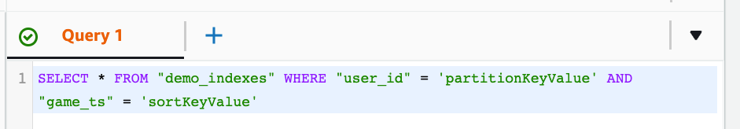

* + Supports some (but not all) statements:
    - INSERT
    - UPDATE
    - SELECT
    - DELETE
  + It supports Batch operations

## DynamoDB – Optimistic Locking

* + DynamoDB has a feature called “Conditional Writes”
  + A strategy to ensure an item hasn’t changed before you update/delete it
  + Each item has an attribute that acts as a *version number*

Client 2

Michael

1



DynamoDB Table

Client 1

Item

2

Lisa

7791a3d6-…

**Version**

**First_Name**

**User_ID**



## DynamoDB Accelerator (DAX)

* + Fully-managed, highly available, seamless in-memory



Application

DAX Cluster

…

Nodes

Amazon DynamoDB

…

Tables

cache for DynamoDB

* + Microseconds latency for cached reads & queries
  + Doesn’t require application logic modification (compatible with existing DynamoDB APIs)
  + Solves the “Hot Key” problem (too many reads)
  + 5 minutes TTL for cache (default)
  + Up to 10 nodes in the cluster
  + Multi-AZ (3 nodes minimum recommended for production)
  + Secure (Encryption at rest with KMS,VPC, IAM, CloudTrail, …)



## DynamoDB Accelerator (DAX) vs. ElastiCache

Amazon ElastiCache



Store Aggregation Result

Application

* Individual objects cache
* Query & Scan cache

DynamoDB Accelerator (DAX)

Amazon DynamoDB

## DynamoDB Streams

* + Ordered stream of item-level modifications (create/update/delete) in a table
  + Stream records can be:
    - Sent to Kinesis Data Streams
    - Read by AWS Lambda
    - Read by Kinesis Client Library applications
  + Data Retention for up to 24 hours
  + Use cases:
    - react to changes in real-time (welcome email to users)
    - Analytics
    - Insert into derivative tables
    - Insert into ElasticSearch
    - Implement cross-region replication

## DynamoDB Streams



**Processing Layer**

KCL App Lambda



Amazon SNS



messaging, notifications

DDB Table



filtering, transforming, …

Application Table DynamoDB Streams



create/update/delete

analytics

Amazon Redshift



archiving

Amazon S3



Kinesis Data Streams

Kinesis Data Firehose

indexing



Amazon ElasticSearch

## DynamoDB Streams

* + Ability to choose the information that will be written to the stream:
    - KEYS_ONLY – only the key attributes of the modified item
    - NEW_IMAGE – the entire item, as it appears after it was modified
    - OLD_IMAGE – the entire item, as it appeared before it was modified
    - NEW_AND_OLD_IMAGES – both the new and the old images of the item
  + DynamoDB Streams are made of shards, just like Kinesis Data Streams
  + You don’t provision shards, this is automated by AWS
  + Records are not retroactively populated in a stream after enabling it

## DynamoDB Streams & AWS Lambda

* + You need to define an Event Source Mapping to read from a DynamoDB Streams

Table

DynamoDB Streams



* + You need to ensure the Lambda function has the appropriate permissions



AWS Lambda

**Event Source Mapping** (internal)

invoke with Event Batch

**Lambda function**

return batch

* Your Lambda function is invoked synchronously

poll



## DynamoDB – Time To Live (TTL)

* + Automatically delete items after an expiry timestamp
  + Doesn’t consume any WCUs (i.e., no extra cost)
  + The TTL attribute must be a “Number” data type with “Unix Epoch timestamp” value
  + Expired items deleted within 48 hours of expiration



* + Expired items, that haven’t been deleted, appears in reads/queries/scans (if you don’t want them, filter them out)

7791a3d6-…

**User_ID**

* + Expired items are deleted from both LSIs and GSIs

873e0634-…

* + A delete operation for each expired item enters the DynamoDB Streams (can help recover expired items)

a80f73a1-…

* + Use cases: reduce stored data by keeping only current items, adhere to regulatory obligations, …

**Current Time**

Friday, September 10, 2021, 11:56:11 AM

**(Epoch timestamp: 1631274971)**



Expiration Process

scan &

**expire** items

**SessionData (Table)**

**Session_ID**

**ExpTime (TTL)**



74686572652

1631188571

6e6f7468696

1631274971



746f2073656

1631102171

scan &

**delete** items



Deletion Process

## DynamoDB CLI – Good to Know

* + --projection-expression: one or more attributes to retrieve
  + --filter-expression: filter items before returned to you
  + General AWS CLI Pagination options (e.g., DynamoDB, S3, …)
    - --page-size: specify that AWS CLI retrieves the full list of items but with a larger number of API calls instead of one API call (default: 1000 items)
    - --max-items: max. number of items to show in the CLI (returns NextToken)
    - --starting-token: specify the last NextToken to retrieve the next set of items

## DynamoDB Transactions

* + Coordinated, all-or-nothing operations (add/update/delete) to multiple items across one or more tables
  + Provides Atomicity, Consistency, Isolation, and Durability (ACID)
  + Read Modes – Eventual Consistency, Strong Consistency,Transactional
  + Write Modes – Standard,Transactional

##### Consumes 2x WCUs & RCUs

* + - DynamoDB performs 2 operations for every item (prepare & commit)
  + Two operations: (up to 25 unique items or up to 4 MB of data)
    - TransactGetItems – one or more GetItem operations
    - TransactWriteItems – one or more PutItem, UpdateItem, and DeleteItem operations
  + Use cases: financial transactions, managing orders, multiplayer games, …

## DynamoDB Transactions

Application



one transaction

**A Transaction is written to both tables, or none!**

**UpdateItem PutItem**

|  |  |  |  |  |  |  |  |  |  |  |  |  |  |  |  |  |  |  |  |
| --- | --- | --- | --- | --- | --- | --- | --- | --- | --- | --- | --- | --- | --- | --- | --- | --- | --- | --- | --- |
| **AccountBalance (Table)** | | | | | |  |  |  |  | **BankTransactions (Table)** | | | | | | | |  | |
| **Account_ID** |  | **Balance** |  | **Last_Tx_ts** |  |  |  |  | **Tx_ID** |  | **Tx_ts** |  | **From_Acc** |  |  | **To_Acc** |  |  | **Amount** |  |  |
|  |  |  |  |  |  |  |  |  |  |  |  |  |  |  |  |  |  |  |  |  |  |
| acc_759692 |  | 230 |  | 1631188571 |  |  |  |  | 75969242… |  | 230 |  | acc_759692 |  |  | acc_315972 |  |  | 45 |  |  |
|  |  |  |  |  |  |  |  |  |  |  |  |  |  |  |  |  |  |  |  |  |  |
| acc_315972 |  | 120 |  | 1631274971 |  |  |  |  | 31597232… |  | 120 |  | acc_315972 |  |  | acc_617055 |  |  | 100 |  |  |
|  |  |  |  |  |  |  |  |  |  |  |  |  |  |  |  |  |  |  |  |  |  |
| acc_617055 |  | 570 |  | 1631102171 |  |  |  |  | 61705584… |  | 570 |  | acc_617055 |  |  | acc_759692 |  |  | 260 |  |  |
|  |  |  |  |  |  |  |  |  |  |  |  |  |  |  |  |  |  |  |  |  |  |

## DynamoDB Transactions – Capacity Computations

* + Important for the exam!
  + Example1: 3 Transactional writes per second, with item size 5 KB
    - We need 3 ∗ ∗ 2 = 30 𝑊𝐶𝑈𝑠

/ 𝐾𝐵

1 𝐾𝐵

𝑡𝑟𝑎𝑛𝑠𝑎𝑐𝑡𝑖𝑜𝑛𝑎𝑙 𝑐𝑜𝑠𝑡

* + Example 2: 5 Transaction reads per second , with item size 5 KB
    - We need 5 ∗ ∗ 2 = 20 𝑅𝐶𝑈𝑠

2 𝐾𝐵

3 𝐾𝐵

𝑡𝑟𝑎𝑛𝑠𝑎𝑐𝑡𝑖𝑜𝑛𝑎𝑙 𝑐𝑜𝑠𝑡

* + - (5 gets rounded to the upper 4 KB)

## DynamoDB as Session State Cache

* + It’s common to use DynamoDB to store session states

##### vs. ElastiCache

* + - ElastiCache is in-memory, but DynamoDB is serverless
    - Both are key/value stores

##### vs. EFS

* + - EFS must be attached to EC2 instances as a network drive

##### vs. EBS & Instance Store

* + - EBS & Instance Store can only be used for local caching, not shared caching

##### vs. S3

* + - S3 is higher latency, and not meant for small objects

## DynamoDB Write Sharding

* + Imagine we have a voting application with two candidates, candidate A and candidate B

|  |  |  |  |  |  |  |
| --- | --- | --- | --- | --- | --- | --- |
| Partition Key |  | Sort Key |  |  | Attributes |  |
| **Candidate_ID** |  | **Vote_ts** |  |  | **Voter_ID** |  |
|  |  |  |  |  |  |  |
| Candidate_A-11 |  | 1631188571 |  |  | 7791 |  |
|  |  |  |  |  |  |  |
| Candidate_B-17 |  | 1631274971 |  |  | 8301 |  |
|  |  |  |  |  |  |  |
|
| Candidate_B-80 |  | 1631102171 |  |  | 6750 |  |
|  |  |  |  |  |  |  |
| Candidate_A-20 |  | 1631102171 |  |  | 2404 |  |

* + If Partition Key is “Candidate_ID”, this results into two partitions, which will generate issues (e.g., Hot Partition)
  + A strategy that allows better distribution of items evenly across partitions
  + Add a suffix to Partition Key value
  + Two methods:
    - Sharding Using Random Suffix
    - Sharding Using Calculated Suffix

Candidate_ID + Random Suffix

## DynamoDB – Write Types

Concurrent Writes Atomic Writes

**Update:** value = 1



**Update:** value = 2

**Update:**

INCREASE value by 1



**Update:**

INCREASE value by 2

The second write overwrites the first write

0

Michael

7791a3d6-…

Both writes succeed,

the value is increased by 3

0

Conditional Writes

Michael

7791a3d6-…

Batch Writes

 

7791a3d6-…

Michael

0

7791a3d6-…

7791a3d6-…

Michael

Michael

0

0

…

The first write is accepted, the second write fails

**Write/Update many items at a time**

**Update:** value = 2 only if value = 0

**Update:** value = 1 only if value = 0



## DynamoDB – Large Objects Pattern



617055.jpg

upload

617055.jpg

download

Application S3 Bucket

**(media-assets-bucket)**

Application

store metadata

**Products (Table)**



get metadata

**Product_Name**

Jeans

**Product_ID**

759692

**Image_URL**

https://media-assets-bucket.us-east-1.amazonaws.com/759692.jpg

315972

Coat

https://media-assets-bucket.us-east-1.amazonaws.com/315972.jpg

617055

Shirt

https://media-assets-bucket.us-east-1.amazonaws.com/617055.jpg

## DynamoDB – Indexing S3 Objects Metadata



upload

invoke

store object’s metadata

Application S3 Bucket

Lambda function

DynamoDB Table

Client



* Search by date
* Total storage used by a customer
* List of all objects with certain attributes
* Find all objects uploaded within a date range

Application

**(API for objects’ metadata)**

## DynamoDB Operations

#### Table Cleanup

* + - Option 1: Scan + DeleteItem
      * Very slow, consumes RCU & WCU, expensive
    - Option 2: Drop Table + Recreate table
      * Fast, efficient, cheap

#### Copying a DynamoDB Table

* + - Option 1: Using AWS Data Pipeline
    - Option 2: Backup and restore into a new table
      * Takes some time
    - Option 3: Scan + PutItem or BatchWriteItem
      * Write your own code

DynamoDB Table



AWS Data Pipeline

launches an

Amazon EMR Cluster

S3 Bucket

## DynamoDB – Security & Other Features

###### Security

* + - VPC Endpoints available to access DynamoDB without using the Internet
    - Access fully controlled by IAM
    - Encryption at rest using AWS KMS and in-transit using SSL/TLS

###### Backup and Restore feature available

* + - Point-in-time Recovery (PITR) like RDS
    - No performance impact

###### Global Tables

* + - Multi-region, multi-active, fully replicated, high performance

###### DynamoDB Local

* + - Develop and test apps locally without accessing the DynamoDB web service (without Internet)
  + AWS Database Migration Service (AWS DMS) can be used to migrate to DynamoDB (from MongoDB, Oracle, MySQL, S3, …)

## DynamoDB –

Users Interact with DynamoDB Directly

Clients/Applications

**(Web & Mobile)**

Obtain IAM Role



permissions

login

temporary AWS credentials



**Identity Providers**

Amazon Cognito User Pools

Google Facebook

OpenID Connect





DynamoDB Table

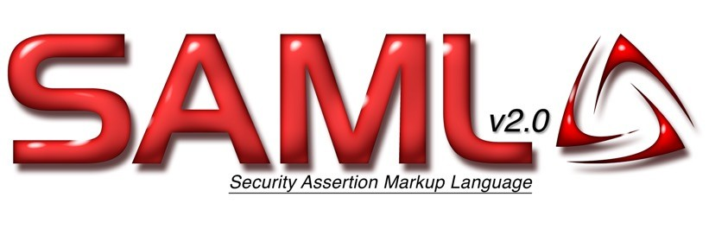

## DynamoDB – Fine-Grained Access Control

* + Using Web Identity Federation or Cognito Identity Pools, each user gets AWS credentials

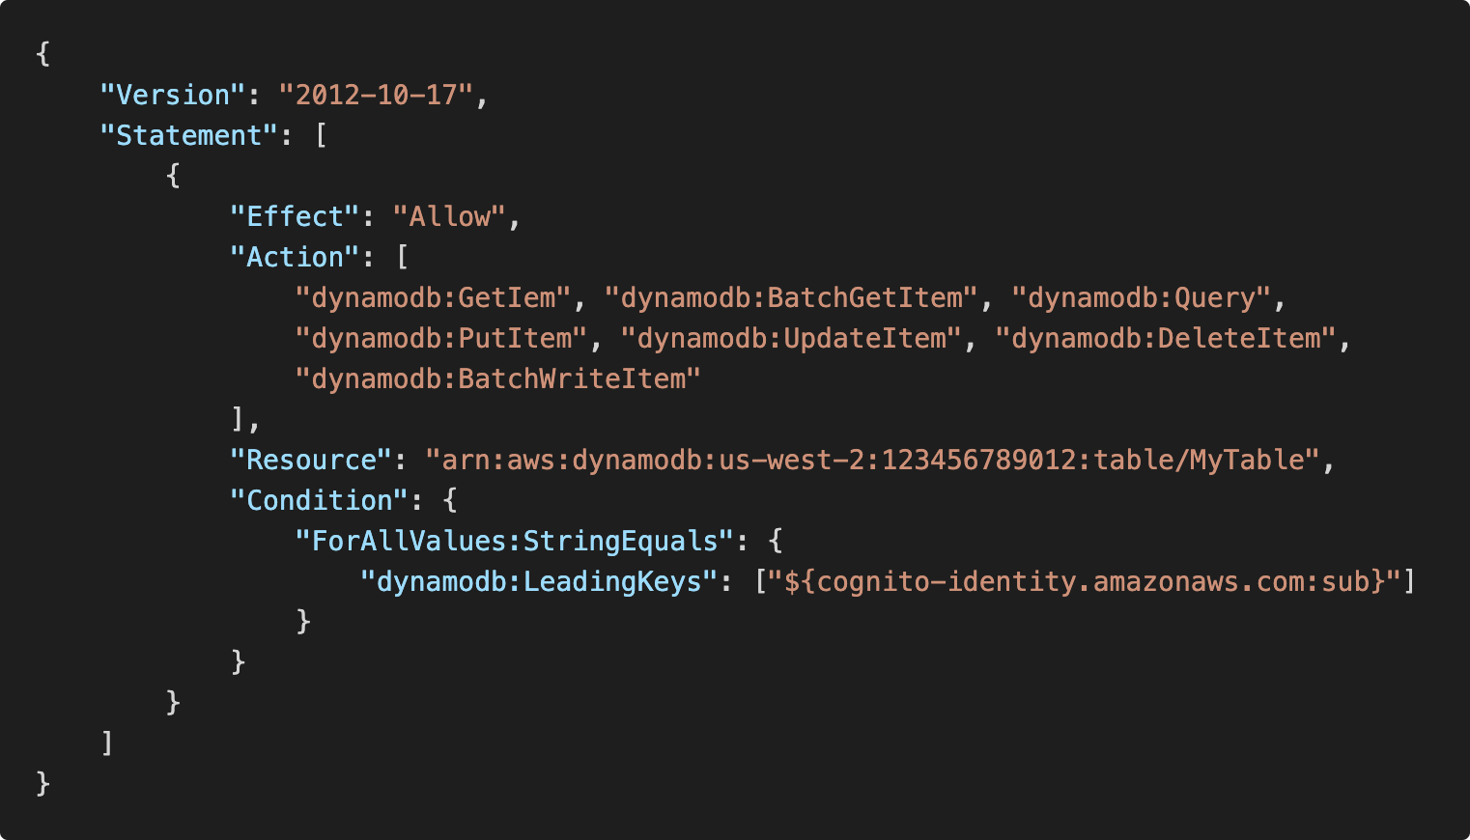

* + You can assign an IAM Role to these users with a Condition to limit their API access to DynamoDB
  + LeadingKeys – limit row-level access for users on the Primary Key
  + Attributes – limit specific attributes the user can see

API Gateway

Build, Deploy and Manage APIs

©

## Example: Building a Serverless API





REST API



PROXY REQUESTS

CRUD

Client

API Gateway

Lambda DynamoDB

## AWS API Gateway

* + - AWS Lambda + API Gateway: No infrastructure to manage
    - Support for the WebSocket Protocol
    - Handle API versioning (v1, v2…)
    - Handle different environments (dev, test, prod…)
    - Handle security (Authentication and Authorization)
    - Create API keys, handle request throttling
    - Swagger / Open API import to quickly define APIs
    - Transform and validate requests and responses
    - Generate SDK and API specifications
    - Cache API responses

## API Gateway – Integrations High Level

#### Lambda Function

* + - * Invoke Lambda function
      * Easy way to expose REST API backed by AWS Lambda

#### HTTP

* + - * Expose HTTP endpoints in the backend
      * Example: internal HTTP API on premise, Application Load Balancer…
      * Why? Add rate limiting, caching, user authentications, API keys, etc…

#### AWS Service

* + - * Expose any AWS API through the API Gateway
      * Example: start an AWS Step Function workflow, post a message to SQS
      * Why? Add authentication, deploy publicly, rate control…

## API Gateway – AWS Service Integration Kinesis Data Streams example



send

records

store **.json**

files

Client



requests

API Gateway Kinesis Data Streams

Kinesis Data Firehose

Amazon S3

## API Gateway - Endpoint Types

* + - Edge-Optimized (default): For global clients
      * Requests are routed through the CloudFront Edge locations (improves latency)
      * The API Gateway still lives in only one region
    - Regional:
      * For clients within the same region
      * Could manually combine with CloudFront (more control over the caching strategies and the distribution)

#### Private:

* + - * Can only be accessed from your VPC using an interface VPC endpoint (ENI)
      * Use a resource policy to define access

## API Gateway – Security

#### User Authentication through

* + - * IAM Roles (useful for internal applications)
      * Cognito (identity for external users – example mobile users)
      * Custom Authorizer (your own logic)
    - Custom Domain Name HTTPS security through integration with AWS Certificate Manager (ACM)
      * If using Edge-Optimized endpoint, then the certificate must be in us-east-1
      * If using Regional endpoint, the certificate must be in the API Gateway region
      * Must setup CNAME or A-alias record in Route 53

## API Gateway – Deployment Stages

* + - Making changes in the API Gateway does not mean they’re effective
    - You need to make a “deployment” for them to be in effect
    - It’s a common source of confusion
    - Changes are deployed to “Stages” (as many as you want)
    - Use the naming you like for stages (dev, test, prod)
    - Each stage has its own configuration parameters
    - Stages can be rolled back as a history of deployments is kept

## API Gateway – Stages v1 and v2 API breaking change

V1



https://api.example.com/v1

v1 Stage

New URL!

V1 Client

V2



https://api.example.com/v2

v2 Stage

V2 Client

## API Gateway – Stage Variables

* + - Stage variables are like environment variables for API Gateway
    - Use them to change often changing configuration values
    - They can be used in:
      * Lambda function ARN
      * HTTP Endpoint
      * Parameter mapping templates
    - Use cases:
      * Configure HTTP endpoints your stages talk to (dev, test, prod…)
      * Pass configuration parameters to AWS Lambda through mapping templates
    - Stage variables are passed to the ”context” object in AWS Lambda

## API Gateway Stage Variables & Lambda Aliases

* + - We create a stage variable to indicate the corresponding Lambda alias
    - Our API gateway will automatically invoke the right Lambda function!

PROD Alias

No API Gateway changes



Prod Stage

95%

TEST Alias

5%

Test Stage

100%

V1

Lambda alias changes

V2

$LATEST

100%

Dev Stage

DEV Alias



## API Gateway – Canary Deployment

* + - Possibility to enable canary deployments for any stage (usually prod)
    - Choose the % of traffic the canary channel receives

v1

95%



Prod Stage

Client 5% **v2**



**Prod Stage Canary**

* + - Metrics & Logs are separate (for better monitoring)
    - Possibility to override stage variables for canary
    - This is blue / green deployment with AWS Lambda & API Gateway

## API Gateway - Integration Types

* + - Integration Type MOCK
      * API Gateway returns a response without sending the request to the backend
    - Integration Type HTTP / AWS (Lambda & AWS Services)
      * you must configure both the integration request and integration response
      * Setup data mapping using mapping templates for the request & response



REST API

AWS Service Integration

Client

API Gateway

+ Mapping Templates

SQS Queue

## API Gateway - Integration Types

* + - Integration Type AWS_PROXY (Lambda Proxy):
      * incoming request from the client is the input to Lambda
      * The function is responsible for the logic of request / response
      * No mapping template, headers, query string parameters… are passed as arguments

**Lambda function expected response**

**Lambda function invocation payload**

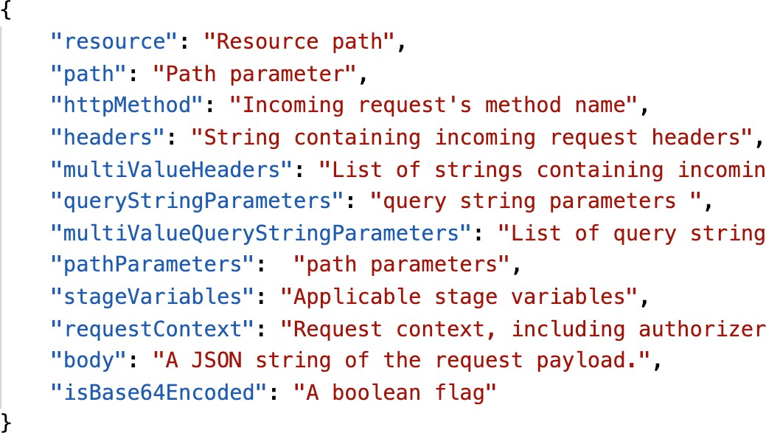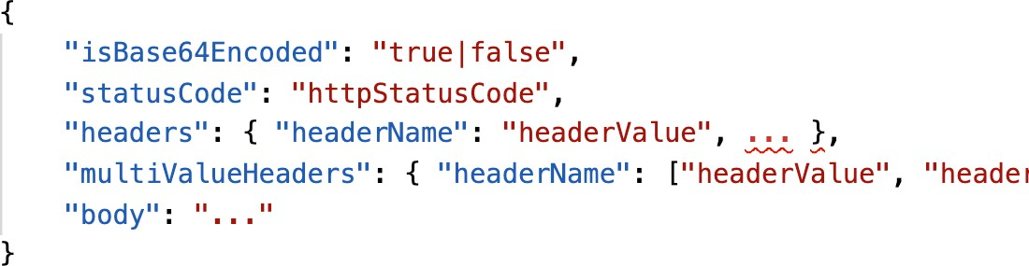

## API Gateway - Integration Types

* + - Integration Type HTTP_PROXY
      * No mapping template
      * The HTTP request is passed to the backend
      * The HTTP response from the backend is forwarded by API Gateway



HTTP Request

HTTP_PROXY

Request/Responses are proxied

Client

API Gateway

Application Load Balancer

## Mapping Templates (AWS & HTTP Integration)

* + - Mapping templates can be used to modify request / responses
    - Rename / Modify query string parameters
    - Modify body content
    - Add headers
    - Uses Velocity Template Language (VTL): for loop, if etc…
    - Filter output results (remove unnecessary data)

## Mapping Example: JSON to XML with SOAP

* + - SOAP API are XML based, whereas REST API are JSON based

Client

API Gateway + Mapping Template

SOAP API



RESTful, JSON Payload

XML Payload

* + - In this case, API Gateway should:
      * Extract data from the request: either path, payload or header
      * Build SOAP message based on request data (mapping template)
      * Call SOAP service and receive XML response
      * Transform XML response to desired format (like JSON), and respond to the user

## Mapping Example: Query String parameters



Client

HTTP

[http://example.com/path**?name=foo&other=bar**](http://example.com/path?name=foo&other=bar)



API Gateway + MAPPING TEMPLATE

JSON

You can rename variables!

{ “my_variable”: “**foo**”, “other_variable”: “**bar**” }

(map them to anything you want)



Lambda

## AWS API Gateway Swagger / Open API spec

* + - Common way of defining REST APIs, using API definition as code
    - Import existing Swagger / OpenAPI 3.0 spec to API Gateway
      * Method
      * Method Request
      * Integration Request
      * Method Response

• + AWS extensions for API gateway and setup every single option

* + - Can export current API as Swagger / OpenAPI spec
    - Swagger can be written in YAML or JSON
    - Using Swagger we can generate SDK for our applications

## Caching API responses



* + - Caching reduces the number of calls made to the backend
    - Default TTL (time to live) is 300 seconds (min: 0s, max: 3600s)

##### Caches are defined per stage

* + - Possible to override cache settings per method
    - Cache encryption option
    - Cache capacity between 0.5GB to 237GB
    - Cache is expensive, makes sense in production, may not make sense in dev / test

**Client**

**API**

**Gateway**



Check cache

Gateway cache

If cache miss

backend

## API Gateway Cache Invalidation

* + - Able to flush the entire cache (invalidate it) immediately

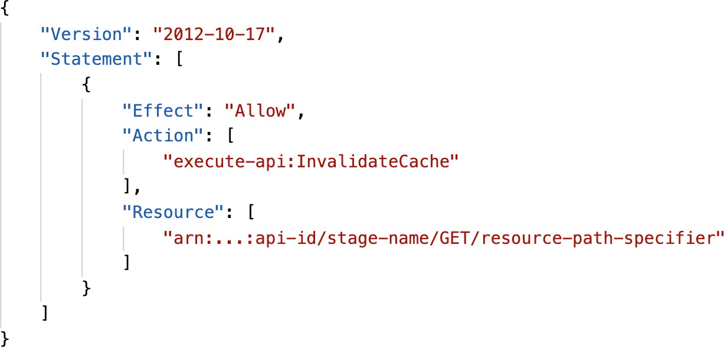

* + - Clients can invalidate the cache with header: Cache- Control: max-age=0 (with proper IAM authorization)
    - If you don't impose

an InvalidateCache policy (or choose the Require authorization check box in the console), any client can invalidate the API cache

## API Gateway – Usage Plans & API Keys

* + - If you want to make an API available as an offering ($) to your customers

##### Usage Plan:

* + - * who can access one or more deployed API stages and methods
      * how much and how fast they can access them
      * uses API keys to identify API clients and meter access
      * configure throttling limits and quota limits that are enforced on individual client

##### API Keys:

* + - * alphanumeric string values to distribute to your customers
      * Ex: WBjHxNtoAb4WPKBC7cGm64CBibIb24b4jt8jJHo9
      * Can use with usage plans to control access
      * Throttling limits are applied to the API keys
      * Quotas limits is the overall number of maximum requests

## API Gateway – Correct Order for API keys

* + - To configure a usage plan

1. Create one or more APIs, configure the methods to require an API key, and deploy the APIs to stages.
2. Generate or import API keys to distribute to application developers (your customers) who will be using your API.
3. Create the usage plan with the desired throttle and quota limits.
4. Associate API stages and API keys with the usage plan.
   * + Callers of the API must supply an assigned API key in the x-api-key header in requests to the API.

## API Gateway – Logging & Tracing

#### CloudWatch Logs:

* + - * Enable CloudWatch logging at the Stage level (with Log Level)
      * Can override settings on a per API basis (ex: ERROR, DEBUG, INFO)
      * Log contains information about request / response body

#### X-Ray:

* + - * Enable tracing to get extra information about requests in API Gateway
      * X-Ray API Gateway + AWS Lambda gives you the full picture

## API Gateway – CloudWatch Metrics

* + - Metrics are by stage, Possibility to enable detailed metrics
    - CacheHitCount & CacheMissCount: efficiency of the cache
    - Count:The total number API requests in a given period.
    - IntegrationLatency:The time between when API Gateway relays a request to the backend and when it receives a response from the backend.
    - Latency:The time between when API Gateway receives a request from a client and when it returns a response to the client.The latency includes the integration latency and other API Gateway overhead.
    - 4XXError (client-side) & 5XXError (server-side)

## API Gateway Throttling

#### Account Limit

* + - * API Gateway throttles requests at10000 rps across all API
      * Soft limit that can be increased upon request
    - In case of throttling => 429 Too Many Requests (retriable error)
    - Can set Stage limit & Method limits to improve performance
    - Or you can define Usage Plans to throttle per customer
    - Just like Lambda Concurrency, one API that is overloaded, if not limited, can cause the other APIs to be throttled

## API Gateway - Errors

##### 4xx means Client errors

* + - * 400: Bad Request
      * 403: Access Denied, WAF filtered
      * 429: Quota exceeded,Throttle

##### 5xx means Server errors

* + - * 502: Bad Gateway Exception, usually for an incompatible output returned from a Lambda proxy integration backend and occasionally for out-of-order invocations due to heavy loads.
      * 503: Service Unavailable Exception
      * 504: Integration Failure – ex Endpoint Request Timed-out Exception

API Gateway requests time out after 29 second maximum

## AWS API Gateway - CORS

* + - CORS must be enabled when you receive API calls from another domain.
    - The OPTIONS pre-flight request must contain the following headers:
      * Access-Control-Allow-Methods
      * Access-Control-Allow-Headers
      * Access-Control-Allow-Origin
    - CORS can be enabled through the console

## CORS – Enabled on the API Gateway

Preflight Request

OPTIONS /

Host: api.example.com

Origin: **https://**[**www.example.com**](http://www.example.com/)

Origin https://[www.example.com](http://www.example.com/)





S3 bucket

static content

Preflight Response

Web Browser

Access-Control-Allow-Origin: **https://**[**www.example.com**](http://www.example.com/)

Access-Control-Allow-Methods: GET, PUT, DELETE

Cross Origin

CORS Headers received previously allowed the origin

The web browser can now make the requests

GET /

Host: api.example.com

Origin: **https://**[**www.example.com**](http://www.example.com/)

## API Gateway – Security

### IAM Permissions

* + - Create an IAM policy authorization and attach to User / Role
    - Authentication = IAM | Authorization = IAM Policy
    - Good to provide access within AWS (EC2, Lambda, IAM users…)
    - Leverages “Sig v4” capability where IAM credential are in headers



**IAM**

IAM Policy check

REST API w/ Sig v4

Client API Gateway Backend

## API Gateway – Resource Policies

* + - Resource policies (similar to Lambda Resource Policy)

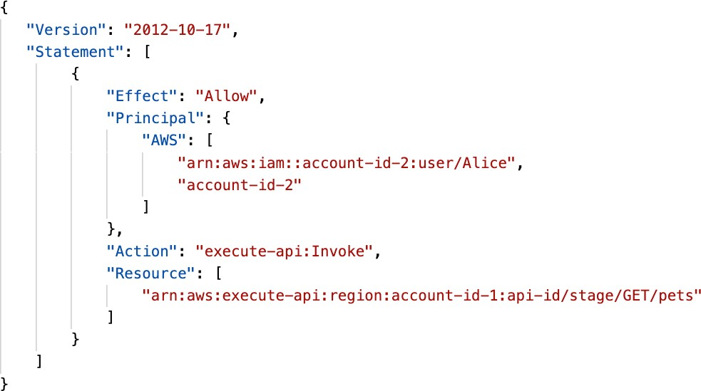

* + - Allow for Cross Account Access (combined with IAM Security)
    - Allow for a specific source IP address
    - Allow for a VPC Endpoint

## API Gateway – Security

### Cognito User Pools

* + - Cognito fully manages user lifecycle, token expires automatically
    - API gateway verifies identity automatically from AWS Cognito
    - No custom implementation required
    - Authentication = Cognito User Pools | Authorization = API Gateway Methods



Authenticate Retrieve token

**Cognito User Pools**

Evaluate Cognito Token

REST API + Pass Token

API Gateway Backend

API Gateway – Security

Lambda Authorizer (formerly Custom Authorizers)

* + - Token-based authorizer (bearer token) – ex JWT (JSON Web Token) or Oauth
    - A request parameter-based Lambda authorizer (headers, query string, stage var)
    - Lambda must return an IAM policy for the user, result policy is cached

###### Authentication = External | Authorization = Lambda function

Authenticate Retrieve token

3rd party Authentication system

Context + token Or request params

Lambda Authorizer

Return IAM Principal



+ IAM Policy

Request w/ Bearer token

**Policy Cache**

**Backend**

**API Gateway**

Or request params



## API Gateway – Security – Summary

###### IAM:

* + - * Great for users / roles already within your AWS account, + resource policy for cross account
      * Handle authentication + authorization
      * Leverages Signature v4

###### Custom Authorizer:

* + - * Great for 3rd party tokens
      * Very flexible in terms of what IAM policy is returned
      * Handle Authentication verification + Authorization in the Lambda function
      * Pay per Lambda invocation, results are cached

###### Cognito User Pool:

* + - * You manage your own user pool (can be backed by Facebook, Google login etc…)
      * No need to write any custom code
      * Must implement authorization in the backend

## API Gateway – HTTP API vs REST API

#### HTTP APIs

* + - * low-latency, cost-effective AWS Lambda proxy, HTTP proxy APIs and private integration (no data mapping)

|  |  |  |
| --- | --- | --- |
| **Authorizers** | **HTTP API** | **REST API** |
| **AWS Lambda** | ✓ | ✓ |
| **IAM** | ✓ | ✓ |
| **Resource Policies** |  | ✓ |
| **Amazon Cognito** | * * | ✓ |
| **Native OpenID Connect**  **/ OAuth 2.0 / JWT** | ✓ |  |

* + - * support OIDC and OAuth 2.0 authorization, and built-in support for CORS
      * No usage plans and API keys

#### REST APIs

* + - * All features (except Native OpenID Connect / OAuth 2.0)

## API Gateway – WebSocket API – Overview



Client 1

CHAT APPLICATION

* + - What’s WebSocket?
      * Two-way interactive communication between a user’s browser and a server
      * Server can push information to the client
      * This enables stateful application use cases
    - WebSocket APIs are often used in real- time applications such as chat applications, collaboration platforms, multiplayer games, and financial trading platforms.

Persistent connection

WebSocket API

* + - Works with AWS Services (Lambda,

DynamoDB) or HTTP endpoints



API Gateway

Lambda function (onConnect)

Lambda function (sendMessage)

Lambda function (onDisconnect)

Amazon DynamoDB



## Connecting to the API

WebSocket URL

wss://[some-uniqueid].execute-api.[region].amazonaws.com/[stage-name]

connect invoke



**connectionId connectionId**

Clients

Amazon API Gateway

WebSocket API

Lambda function (onConnect)

Amazon DynamoDB

## Client to Server Messaging

### ConnectionID is re-used

WebSocket URL

wss://abcdef.execute-api.us-west-1.amazonaws.com/dev

send message



invoke

**connectionId**

**connectionId**



Clients

frames

frames

Amazon API Gateway

WebSocket API

Lambda function (sendMessage)

Amazon DynamoDB

## Server to Client Messaging

WebSocket URL

wss://abcdef.execute-api.us-west-1.amazonaws.com/dev

send message



invoke

connectionId

connectionId



Clients

Amazon API Gateway

WebSocket API

HTTP POST (IAM Sig v4)

Connection URL callback

Lambda function (sendMessage)

Amazon DynamoDB

**Connection URL**

## Connection URL Operations

**Connection URL**

wss://abcdef.execute-api.us-west-1.amazonaws.com/dev/@connections/connectionId

|  |  |
| --- | --- |
| **Operation** | **Action** |
| POST | Sends a message from the Server to the connected WS Client |
| GET | Gets the latest connection status of the connected WS Client |
| DELETE | Disconnect the connected Client from the WS connection |

## API Gateway – WebSocket API – Routing

INCOMING DATA

* + - Incoming JSON messages are routed to {

different backend

* + - If no routes => sent to $default
    - You request a *route selection expression* to select the field on JSON to route from }
    - Sample expression: $request.body.action
    - The result is evaluated against the route keys available in your API Gateway
    - The route is then connected to the backend you’ve setup through API Gateway

"service" : "chat", "data" : {

"room" : "room1234"

"action" : "join",

}

ROUTE KEY TABLE – API GATEWAY

|  |
| --- |
| $connect |
| $disconnect |
| $default |
| join |
| quit |
| delete |
| … |

Backend integration

## API Gateway - Architecture



Client Client

* + - Create a single interface for all the microservices in your company
    - Use API endpoints with various resources

customer1.example.com

customer2.example.com

API Gateway



Route 53

* + - Apply a simple domain name and SSL certificates

/service1

/docs

Domain Registrar, DNS

/service2

* + - Can apply forwarding and transformation rules at the API Gateway level

ELB ELB

S3 Bucket

Amazon EC2 Auto Scaling

ECS Cluster (Microservices)

AWS Serverless Application Model (SAM)

Taking your Serverless Development to the next level



## AWS SAM

* + - SAM = Serverless Application Model
    - Framework for developing and deploying serverless applications
    - All the configuration is YAML code
    - Generate complex CloudFormation from simple SAM YAML file
    - Supports anything from CloudFormation: Outputs, Mappings, Parameters, Resources…N
    - Only two commands to deploy to AWS
    - SAM can use CodeDeploy to deploy Lambda functions
    - SAM can help you to run Lambda, API Gateway, DynamoDB locally

## AWS SAM – Recipe

#### Transform Header indicates it’s SAM template:

* + - * Transform: 'AWS::Serverless-2016-10-31'

#### Write Code

* + - * AWS::Serverless::Function
      * AWS::Serverless::Api
      * AWS::Serverless::SimpleTable

#### Package & Deploy:

* + - * aws cloudformation package / sam package
      * aws cloudformation deploy / sam deploy

## Deep Dive into SAM Deployment

**Build the application locally**

(sam build)

**Package the application**

(sam package OR



aws cloudformation package)

**Deploy the application**

(sam deploy OR

aws cloudformation deploy)

transform zip & upload create/execute ChangeSet

S3 Bucket

CloudFormation Template

**(YAML)**

+

SAM Template

**(YAML)**

+

CloudFormation



Application Code

Application Code

API Gateway DynamoDB

Lambda

CloudFormation Stack



## SAM – CLI Debugging

* + - Locally build, test, and debug your serverless applications that are defined using AWS SAM templates
    - Provides a lambda-like execution environment locally
    - SAM CLI + AWS Toolkits => step-through and debug your code
    - Supported IDEs: AWS Cloud9,Visual Studio Code, JetBrains, PyCharm, IntelliJ, …
    - AWS Toolkits: IDE plugins which allows you to build, test, debug, deploy, and invoke Lambda functions built using AWS SAM

+

AWS Toolkits For



VS Code

AWS Cloud9



IntelliJ

PyCharm

debug code locally (step-through it line by line)



SAM CLI



JetBrains

…

Lambda function

code

## SAM Policy Templates

* + - List of templates to apply permissions to your Lambda Functions

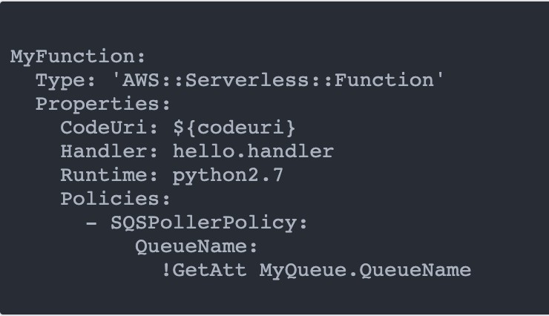

* + - Full list available here: https://docs.aws.amazon.com/serverless- application- model/latest/developerguide/serverless- policy-templates.html#serverless-policy- template-table
    - Important examples:
      * S3ReadPolicy: Gives read only permissions to objects in S3
      * SQSPollerPolicy: Allows to poll an SQS queue
      * DynamoDBCrudPolicy: CRUD = create read update delete

## SAM and CodeDeploy

* + - SAM framework natively uses CodeDeploy to update Lambda functions
    - Traffic Shifting feature
    - Pre and Post traffic hooks features to validate deployment (before the traffic shift starts and after it ends)
    - Easy & automated rollback using CloudWatch Alarms



*Trigger deployment (CICD)*



CodeDeploy

CloudWatch Alarm



*Traffic shifting*

Lambda Alias

v1

*with alias*

v2



*Run tests*



Lambda Function Pre-Traffic Hook

*Run tests*

Lambda Function Post-Traffic Hook



## SAM – Exam Summary

* + - SAM is built on CloudFormation
    - SAM requires the Transform and Resources sections
    - Commands to know:
      * sam build: fetch dependencies and create local deployment artifacts
      * sam package: package and upload to Amazon S3, generate CF template
      * sam deploy: deploy to CloudFormation
    - SAM Policy templates for easy IAM policy definition
    - SAM is integrated with CodeDeploy to do deploy to Lambda aliases

## Serverless Application Repository (SAR)

* + - Managed repository for serverless applications



S3 Bucket

Serverless Application Repository

Account

* + - The applications are packaged using SAM
    - Build and publish applications that can be re-used by organizations
      * Can share publicly
      * Can share with specific AWS accounts

deploy

publish

* + - This prevents duplicate work, and just go straight to publishing
    - Application settings and behaviour can be customized using Environment variables

AWS Cloud Development Kit

©

## AWS Cloud Development Kit (CDK)

* Define your cloud infrastructure using a familiar language:

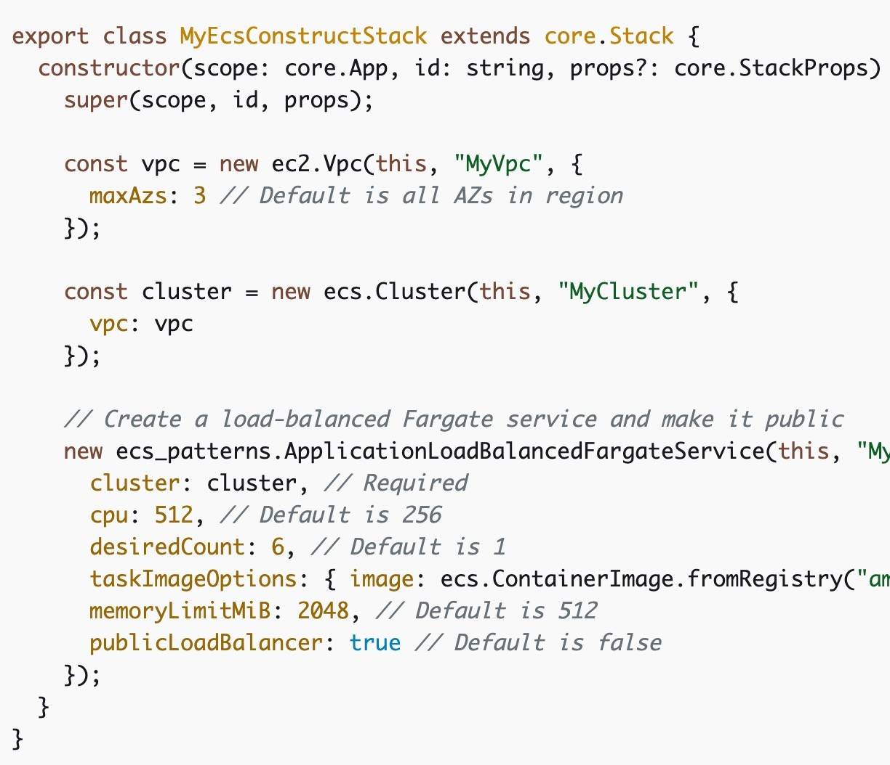

* + JavaScript/TypeScript, Python, Java, and .NET
* Contains high level components called

constructs

* The code is “compiled” into a CloudFormation template (JSON/YAML)

###### You can therefore deploy infrastructure and application runtime code together

* + Great for Lambda functions
  + Great for Docker containers in ECS / EKS

## CDK in a diagram

CDK Application Constructs



CDK CLI

CloudFormation Template

CloudFormation

cdk synth

Programming Languages

## CDK vs SAM

* SAM:
  + Serverless focused
  + Write your template declaratively in JSON or YAML
  + Great for quickly getting started with Lambda
  + Leverages CloudFormation
* CDK:
  + All AWS services
  + Write infra in a programming language JavaScript/TypeScript, Python, Java, and

.NET

* + Leverages CloudFormation

## CDK Hands-On

Amazon Rekognition



Client

Upload image

S3 Bucket

trigger

AWS Lambda

save results

Amazon DynamoDB

Amazon Cognito Section

©

## Amazon Cognito

* + - We want to give our users an identity so that they can interact with our application.

##### Cognito User Pools:

* + - * Sign in functionality for app users
      * Integrate with API Gateway & Application Load Balancer

##### Cognito Identity Pools (Federated Identity):

* + - * Provide AWS credentials to users so they can access AWS resources directly
      * Integrate with Cognito User Pools as an identity provider

##### Cognito Sync:

* + - * Synchronize data from device to Cognito.
      * Is deprecated and replaced by AppSync
    - Cognito vs IAM: “hundreds of users”, ”mobile users”, “authenticate with SAML”

## Cognito User Pools (CUP) – User Features

* + - Create a serverless database of user for your web & mobile apps
    - Simple login: Username (or email) / password combination
    - Password reset
    - Email & Phone Number Verification
    - Multi-factor authentication (MFA)
    - Federated Identities: users from Facebook, Google, SAML…
    - Feature: block users if their credentials are compromised elsewhere
    - Login sends back a JSON Web Token (JWT)

## Cognito User Pools (CUP) – Diagram

Mobile Applications

Returns JSON Web Token

JWT





Social Identity Provider

login

Cognito User Pools



Web Applications



Database of users

Federation through

Third Party Identity Provider (IdP)

## Cognito User Pools (CUP) - Integrations

* + - CUP integrates with API Gateway and Application Load Balancer

Authenticate Retrieve token



Cognito User Pools

Authenticate

Cognito User Pools



REST API +

Pass Token

Evaluate Cognito Token



Application Load Balancer

+ Listeners & Rules

**API Gateway** backend



Target Group



Backend

## Cognito User Pools – Lambda Triggers

* + - CUP can invoke a Lambda function synchronously on these triggers:

|  |  |
| --- | --- |
| **User Pool Flow** | **Operation Description** |
| **Authentication Events** | Pre Authentication Lambda Trigger Custom validation to accept or deny the sign-in request |
| Post Authentication Lambda Trigger Event logging for custom analytics |
| Pre Token Generation Lambda Trigger Augment or suppress token claims |
| **Sign-Up** | Pre Sign-up Lambda Trigger Custom validation to accept or deny the sign-up request |
| Post Confirmation Lambda Trigger Custom welcome messages or event logging for  custom analytics |
| Migrate User Lambda Trigger Migrate a user from an existing user directory to user  pools |
| **Messages** | Custom Message Lambda Trigger Advanced customization and localization of messages |
| **Token Creation** | Pre Token Generation Lambda Trigger Add or remove attributes in Id tokens |

## Cognito User Pools – Hosted Authentication UI

* + - Cognito has a hosted authentication UI that you can add to your app to handle sign- up and sign-in workflows



* + - Using the hosted UI, you have a foundation for integration with social logins, OIDC or SAML
    - Can customize with a custom logo and custom CSS

## Cognito Identity Pools (Federated Identities)

* + - Get identities for “users” so they obtain temporary AWS credentials
    - Your identity pool (e.g identity source) can include:
      * Public Providers (Login with Amazon, Facebook, Google, Apple)
      * Users in an Amazon Cognito user pool
      * OpenID Connect Providers & SAML Identity Providers
      * Developer Authenticated Identities (custom login server)
      * Cognito Identity Pools allow for unauthenticated (guest) access
    - Users can then access AWS services directly or through API Gateway
      * The IAM policies applied to the credentials are defined in Cognito
      * They can be customized based on the user_id for fine grained control

## Cognito Identity Pools – Diagram

Login and Get Token





Social Identity Provider

Cognito User Pools

Web & Mobile Applications



Exchange token **Cognito Identity Pools**



for temporary



AWS credentials validate

Direct access to AWS



Get temp creds



**DynamoDB Table**

**Private S3 Bucket**

## Cognito Identity Pools – Diagram with CUP

Login and Get Token



Cognito User Pools



Web & Mobile Applications



Exchange token for temporary

Cognito Identity Pools



Direct access to AWS

AWS credentials validate



Internal DB of users



Get temp creds



**DynamoDB Table**

**Private S3 Bucket**



©

## Cognito Identity Pools – IAM Roles

* + - Default IAM roles for authenticated and guest users
    - Define rules to choose the role for each user based on the user’s ID
    - You can partition your users’ access using policy variables
    - IAM credentials are obtained by Cognito Identity Pools through STS
    - The roles must have a “trust” policy of Cognito Identity Pools

## Cognito Identity Pools – Guest User example

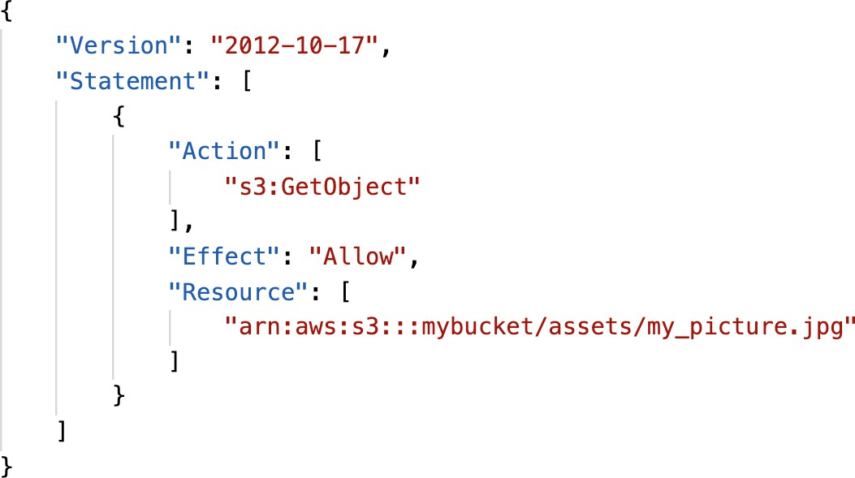

Cognito Identity Pools – Policy variable on S3

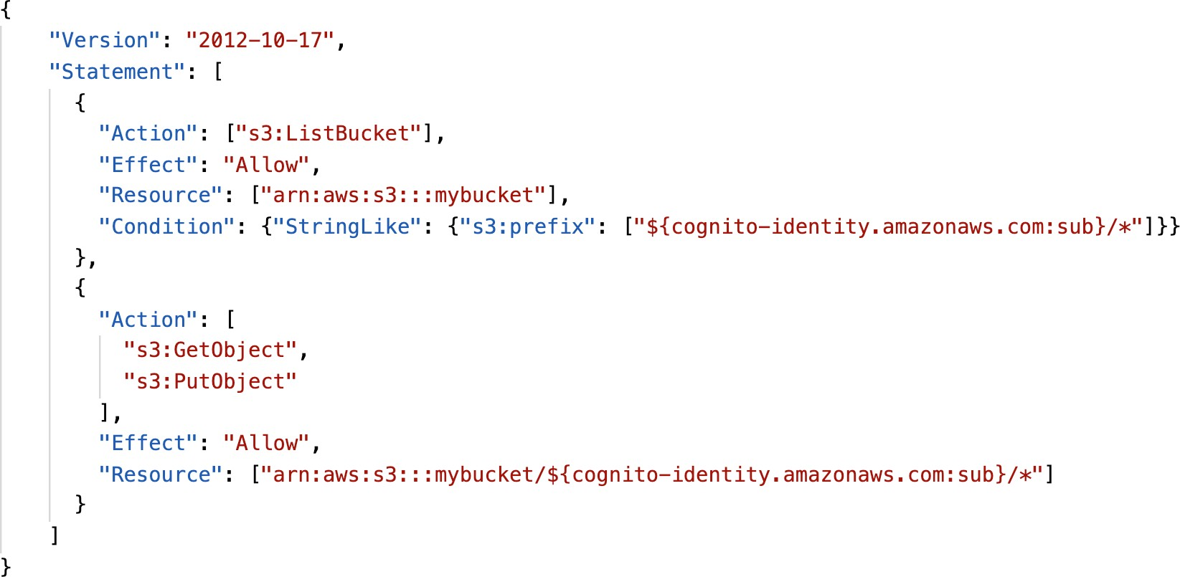

Cognito Identity Pools – DynamoDB

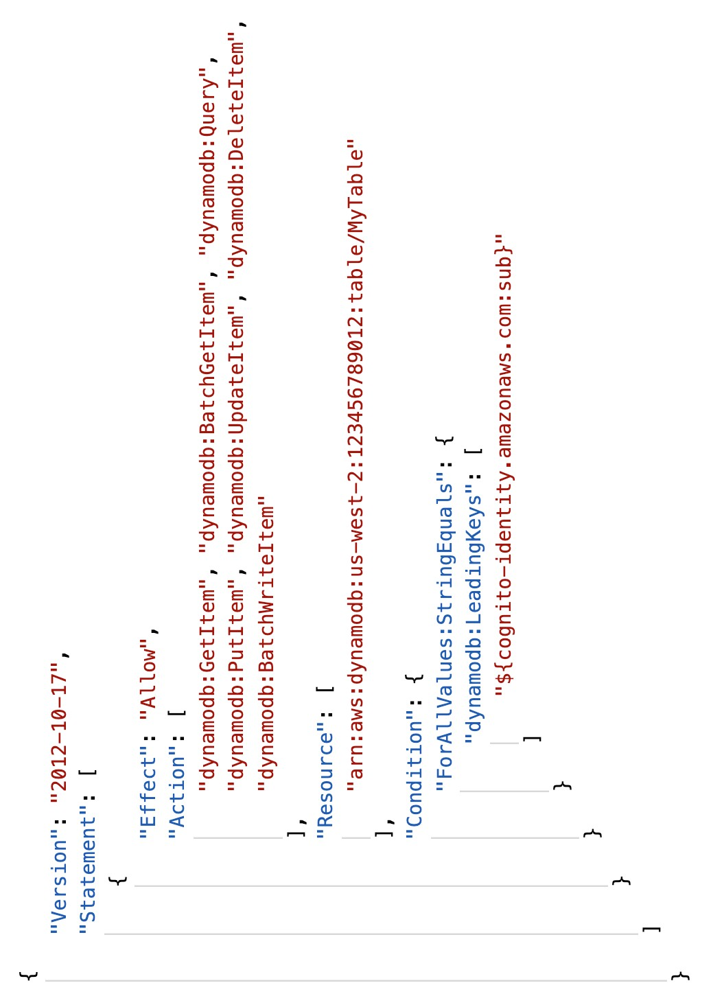

## Cognito User Pools vs Identity Pools

#### Cognito User Pools:

* + - * Database of users for your web and mobile application
      * Allows to federate logins through Public Social, OIDC, SAML…
      * Can customize the hosted UI for authentication (including the logo)]
      * Has triggers with AWS Lambda during the authentication flow

#### Cognito Identity Pools:

* + - * Obtain AWS credentials for your users
      * Users can login through Public Social, OIDC, SAML & Cognito User Pools
      * Users can be unauthenticated (guests)
      * Users are mapped to IAM roles & policies, can leverage policy variables
    - CUP + CIP = manage user / password + access AWS services

## Cognito Identity Pools – Diagram with CUP

Login and Get Token



Cognito User Pools



Web & Mobile Applications



Exchange token for temporary

Cognito Identity Pools



Direct access to AWS

AWS credentials validate



Internal DB of users



Get temp creds



**DynamoDB Table**

**Private S3 Bucket**



## Cognito Sync

* + - Deprecated – use AWS AppSync now
    - Store preferences, configuration, state of app
    - Cross device synchronization (any platform – iOS, Android, etc…)
    - Offline capability (synchronization when back online)
    - Store data in datasets (up to 1MB), up to 20 datasets to synchronize
    - Push Sync: silently notify across all devices when identity data changes
    - Cognito Stream: stream data from Cognito into Kinesis
    - Cognito Events: execute Lambda functions in response to events

Other Serverless Section

## AWS Step Functions

* + - Model your workflows as state machines (one per workflow)

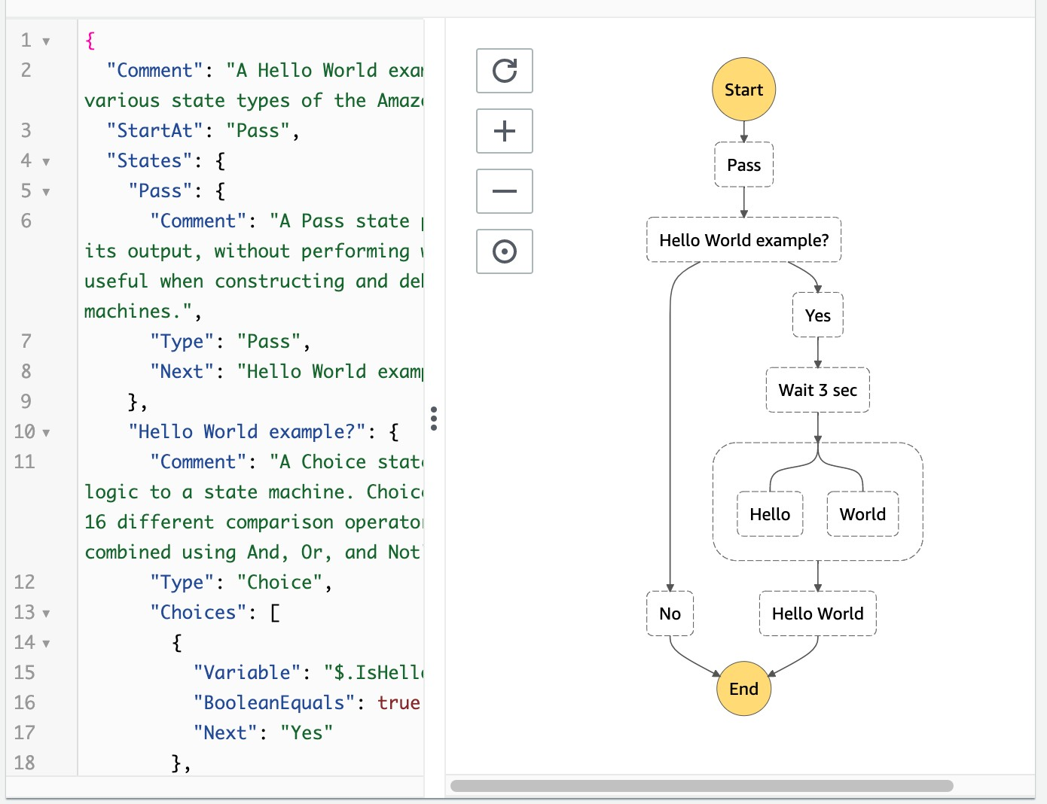

* + - * Order fulfillment, Data processing
      * Web applications, Any workflow
    - Written in JSON
    - Visualization of the workflow and the execution of the workflow, as well as history
    - Start workflow with SDK call, API Gateway, Event Bridge (CloudWatch Event)

©

## Step Function – Task States

* + - Do some work in your state machine
    - Invoke one AWS service
      * Can invoke a Lambda function
      * Run an AWS Batch job
      * Run an ECS task and wait for it to complete
      * Insert an item from DynamoDB
      * Publish message to SNS, SQS
      * Launch another Step Function workflow…
    - Run an one Activity
      * EC2, Amazon ECS, on-premises
      * Activities poll the Step functions for work
      * Activities send results back to Step Functions

App server

Lambda Batch ECS

 

DynamoDB



**Task State**

SNS SQS

Activity Task



Poll for work Send results

Example – Invoke Lambda Function

©

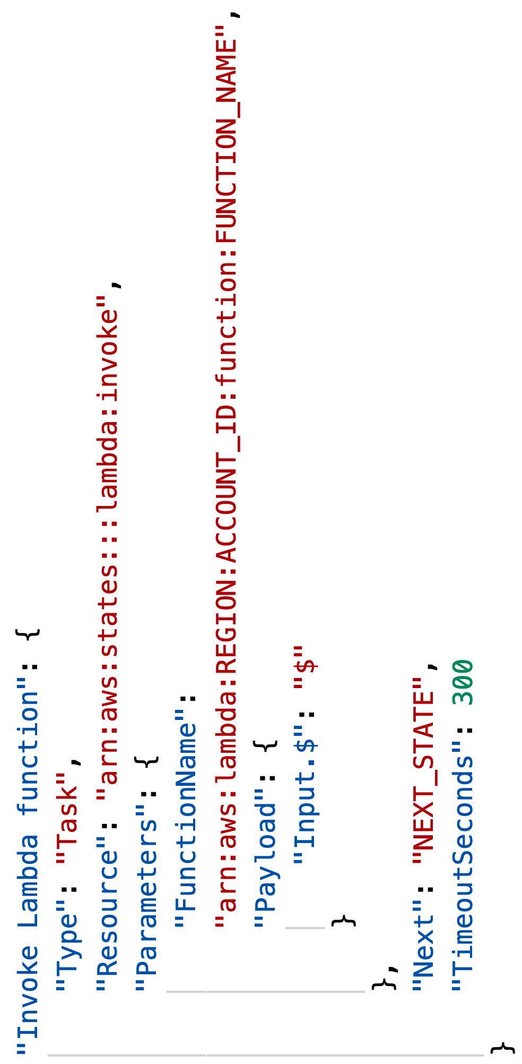

## Step Function - States

* Choice State - Test for a condition to send to a branch (or default branch)
* Fail or Succeed State - Stop execution with failure or success
* Pass State - Simply pass its input to its output or inject some fixed data, without performing work.
* Wait State - Provide a delay for a certain amount of time or until a specified time/date.
* Map State - Dynamically iterate steps.’
* *Parallel State - Begin parallel branches of execution.*

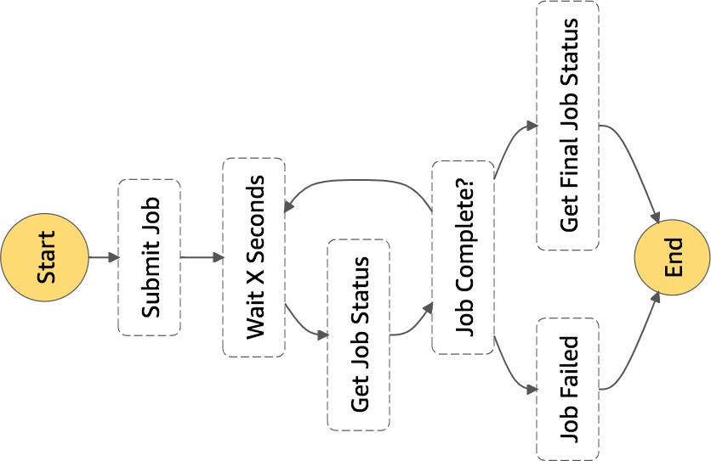

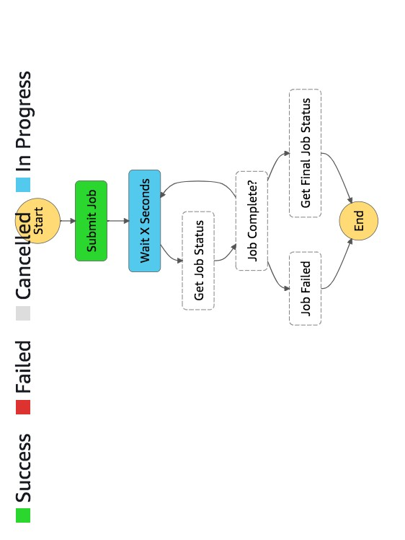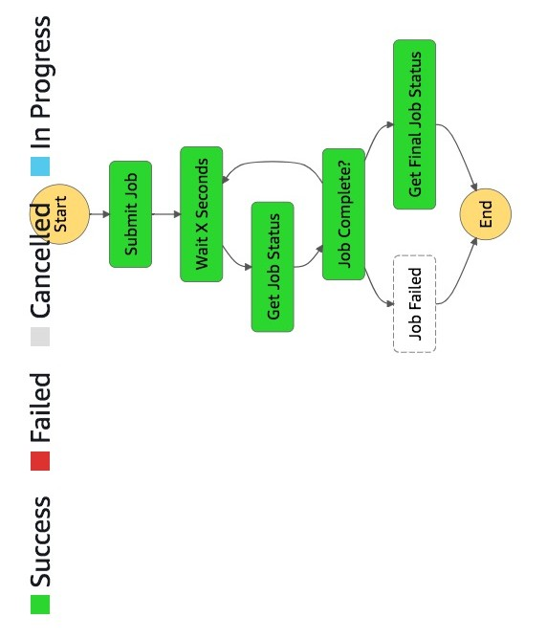

Visual workflow in Step Functions

©

## Error Handling in Step Functions

* + Any state can encounter runtime errors for various reasons:
    - State machine definition issues (for example, no matching rule in a Choice state)
    - Task failures (for example, an exception in a Lambda function)
    - Transient issues (for example, network partition events)
  + Use Retry (to retry failed state) and Catch (transition to failure path) in the State Machine to handle the errors instead of inside the Application Code
  + Predefined error codes:
    - States.ALL : matches any error name
    - States.Timeout:Task ran longer than TimeoutSeconds or no heartbeat received
    - States.TaskFailed: execution failure
    - States.Permissions: insufficient privileges to execute code
  + The state may report is own errors

## Step Functions – Retry (Task or Parallel State)

* + - Evaluated from top to bottom

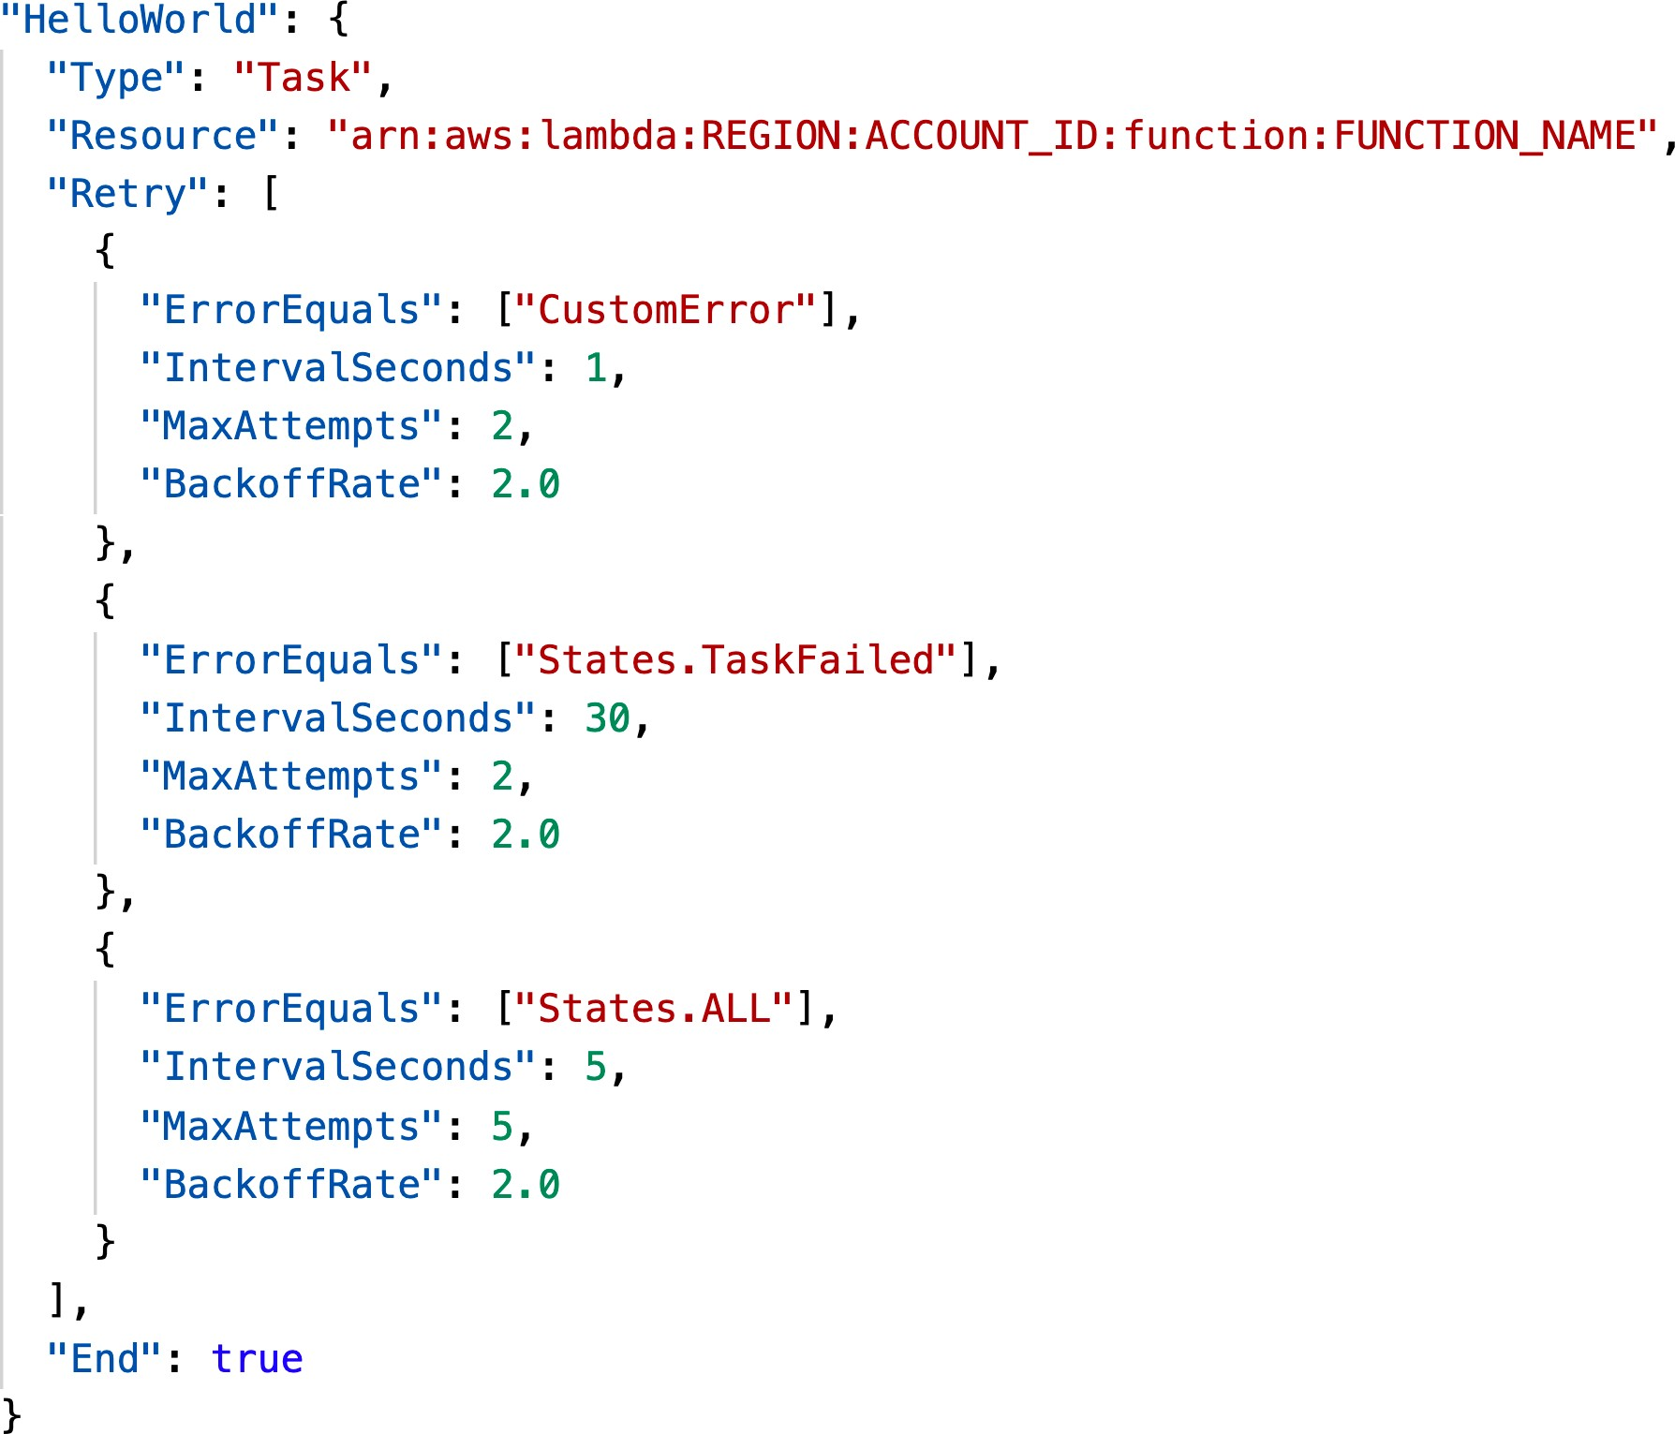

* + - ErrorEquals: match a specific kind of error
    - IntervalSeconds: initial delay before retrying
    - BackoffRate: multiple the delay after each retry
    - MaxAttempts: default to 3, set to 0 for never retried
    - When max attempts are reached, the Catch kicks in

## Step Functions – Catch (Task or Parallel State)

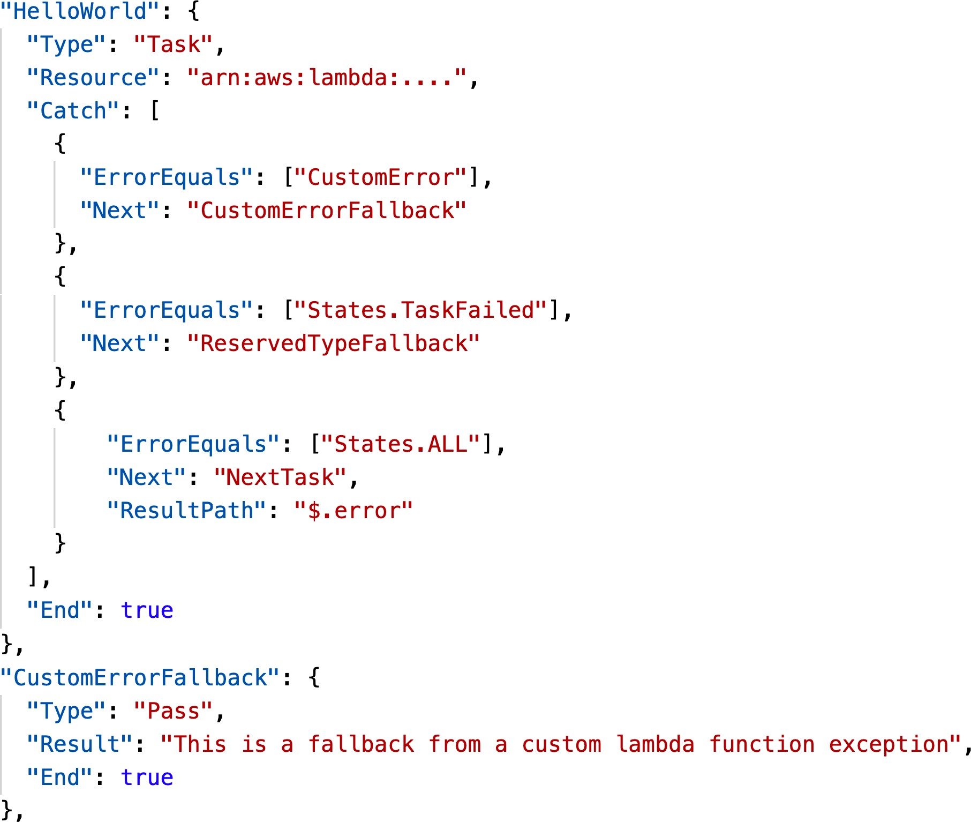

* + - Evaluated from top to bottom
    - ErrorEquals: match a specific kind of error
    - Next: State to send to
    - ResultPath - A path that determines what input is sent to the state specified in the Next field.

## Step Function – ResultPath

* Include the error in the input

INPUT

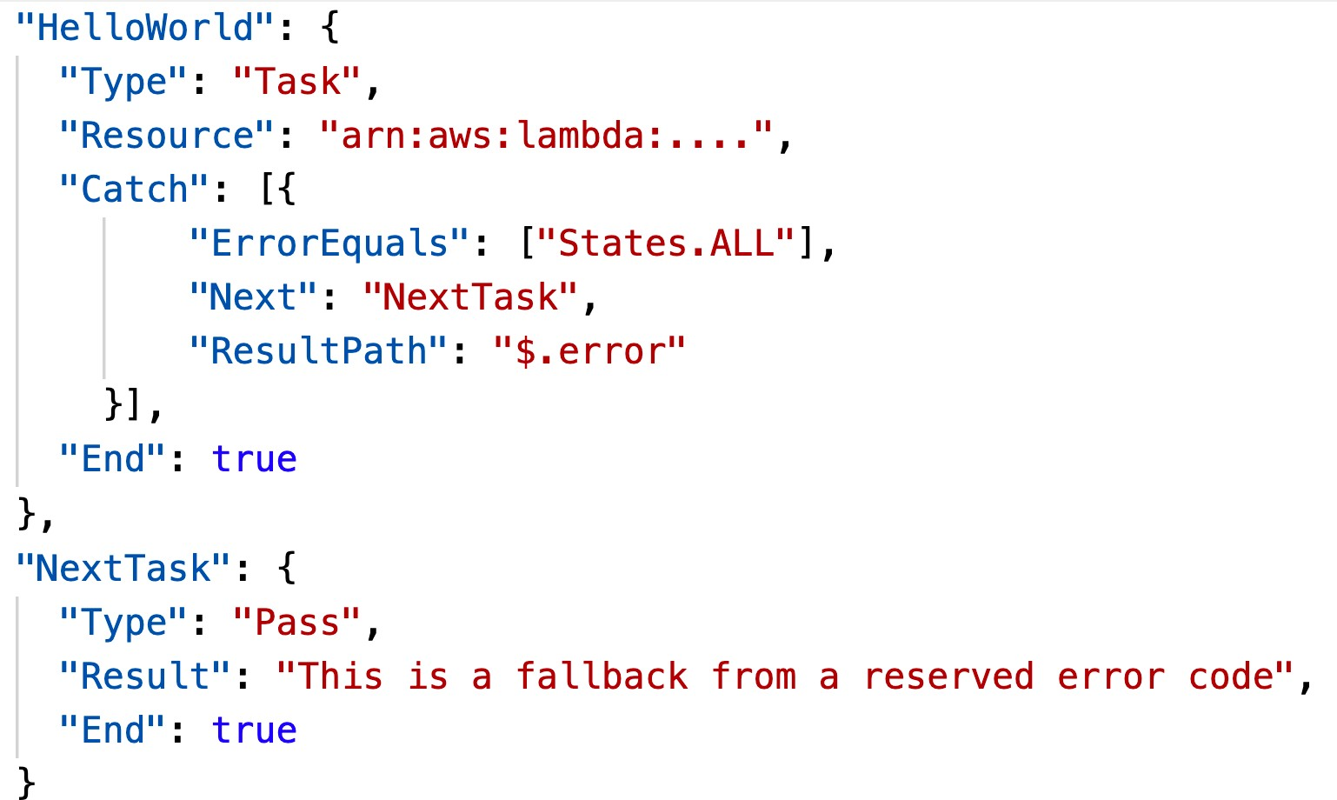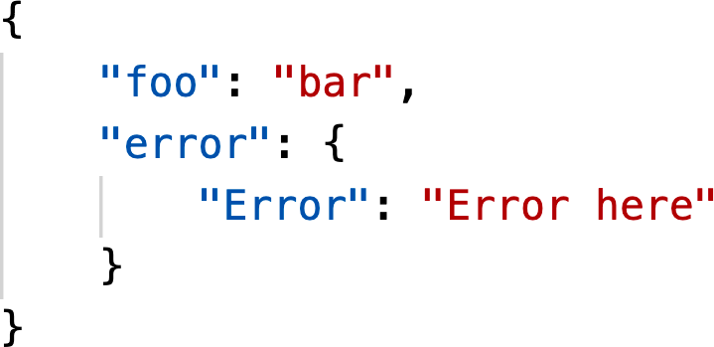

OUTPUT WITH ERROR

USING RESULTPATH

## Step Functions – Standard vs Express

|  |  |  |
| --- | --- | --- |
| **Standard Workflows** | | **Express Workflows** |
| **Maximum duration** | 1 year. | 5 minutes. |
| **Supported execution start rate** | Over 2,000 per second | Over 100,000 per second |
| **Supported state transition rate** | Over 4,000 per second per account | Nearly unlimited |
| **Pricing** | Priced per state transition. A state transition is | Priced by the number of executions you run, |
|  | counted each time a step in your execution is | their duration, and memory consumption |
|  | completed (more expensive) | (cheaper) |
| **Execution history** | Executions can be listed and described with Step | Executions can be inspected in CloudWatch |
|  | Functions APIs, and visually debugged through | Logs by enabling logging on your state |
|  | the console. They can also be inspected in | machine. |
|  | CloudWatch Logs by enabling logging on your |  |
|  | state machine. |  |
| **Execution semantics** | Exactly-once workflow execution. | At-least-once workflow execution. |

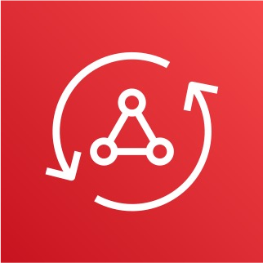AWS AppSync - Overview

* + AppSync is a managed service that uses GraphQL
  + GraphQL makes it easy for applications to get exactly the data they need.
  + This includes combining data from one or more sources
    - NoSQL data stores, Relational databases, HTTP APIs…
    - Integrates with DynamoDB, Aurora, Elasticsearch & others
    - Custom sources with AWS Lambda
  + Retrieve data in real-time with WebSocket or MQTT on WebSocket
  + For mobile apps: local data access & data synchronization
  + It all starts with uploading one GraphQL schema

## GraphQL example

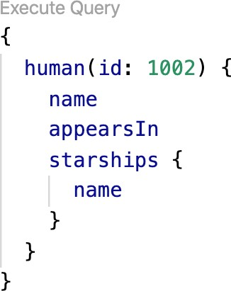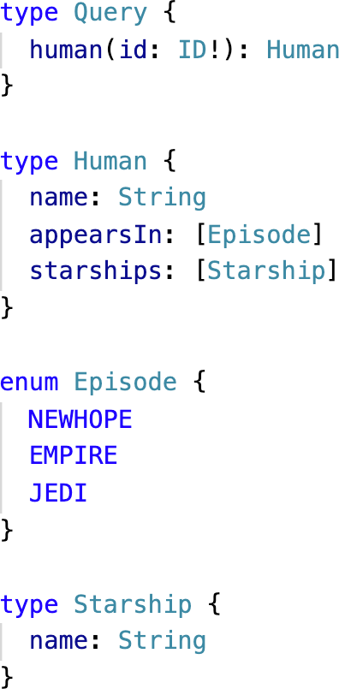

GraphQL query sent by clients



Schema uploaded

AppSync

Client

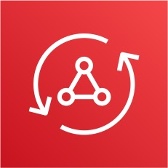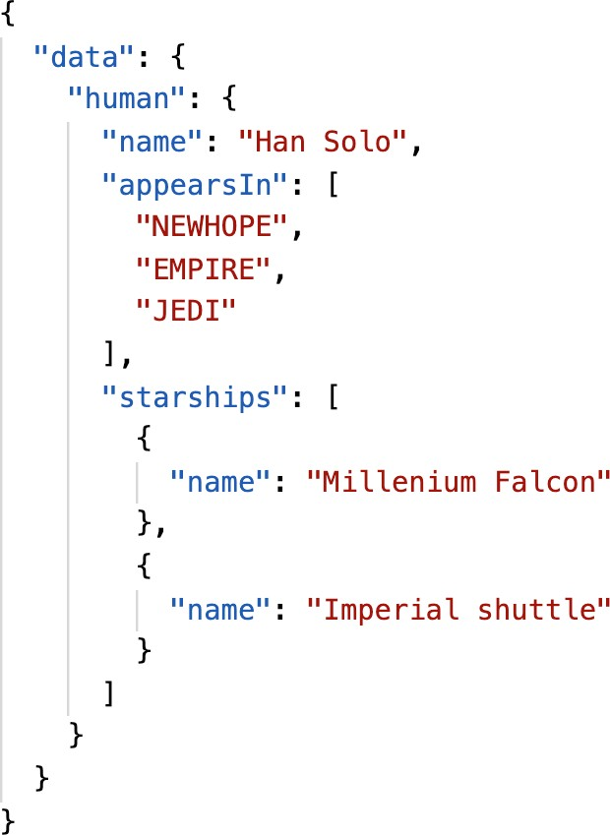

GraphQL Schema on AppSync

DynamoDB Resolver



DynamoDB

GraphQL Response in JSON

## AppSync Diagram

DynamoDB

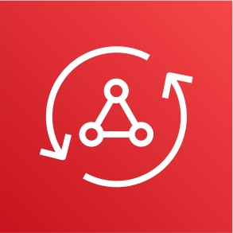

**AppSync**

**GraphQL Schema**

**Resolvers**

CloudWatch Metrics & Logs



 Web apps

Mobile apps

Real-time dashboards

 Offline Sync

Aurora

ElasticSearch Service

Lambda

Anything

HTTP

Public HTTP APIs

## AppSync – Security

* + There are four ways you can authorize applications to interact with your AWS AppSync GraphQL API:
  + API_KEY
  + AWS_IAM: IAM users / roles / cross-account access
  + OPENID_CONNECT: OpenID Connect provider / JSON Web Token
  + AMAZON_COGNITO_USER_POOLS
  + For custom domain & HTTPS, use CloudFront in front of AppSync

## AWS Amplify

Create mobile and web applications

Amplify Studio

Visually build a full-stack app, both front-end UI and a backend.

Amplify Libraries

Connect your app to existing AWS Services (Cognito, S3 and more)

Amplify CLI

Configure an Amplify backend With a guided CLI workflow

Amplify Hosting

Host secure, reliable, fast web apps or websites via the AWS content delivery network.

## AWS Amplify

* + Set of tools to get started with creating mobile and web applications
  + “Elastic Beanstalk for mobile and web applications”
  + Must-have features such as data storage, authentication, storage, and machine-learning, all powered by AWS services
  + Front-end libraries with ready-to-use components for React.js,Vue, Javascript, iOS, Android, Flutter, etc…
  + Incorporates AWS best practices to for reliability, security, scalability
  + Build and deploy with the Amplify CLI or

Amplify Studio

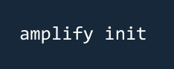

Connect With Amplify Frontend Libs

Frontend



Build



Amplify Studio & CLI



DynamoDB



AWS

AppSync



Amazon Cognito



Amazon S3

Amplify backend

## AWS Amplify – Important Features

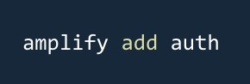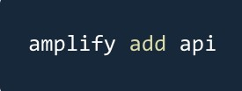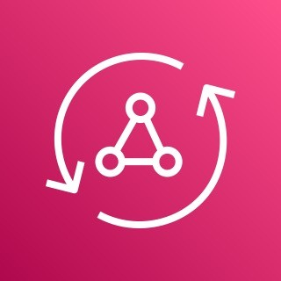

AUTHENTICATION

* + Leverages Amazon Cognito
  + User registration, authentication, account recovery & other operations
  + Support MFA, Social Sign-in, etc…
  + Pre-built UI components
  + Fine-grained authorization

DATASTORE

* Leverages Amazon AppSync and Amazon DynamoDB
* Work with local data and have automatic synchronization to the cloud without complex code
* Powered by GraphQL
* Offline and real-time capabilities
* Visual data modeling w/ Amplify Studio

## AWS Amplify Hosting

AMPLIFY HOSTING

* Build and Host Modern Web Apps

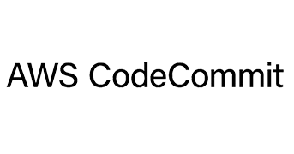

CloudFront

deploy

Amplify

deploy

(optionally) Build Back End

Build Front End

**Source Code Repository**

* CICD (build, test, deploy)
* Pull Request Previews
* Custom Domains
* Monitoring
* Redirect and Custom Headers
* Password protection

Advanced Identity Section

©

## AWS STS – Security Token Service

* Allows to grant limited and temporary access to AWS resources (up to 1 hour).
* AssumeRole: Assume roles within your account or cross account
* AssumeRoleWithSAML: return credentials for users logged with SAML

###### AssumeRoleWithWebIdentity

* + return creds for users logged with an IdP (Facebook Login, Google Login, OIDC compatible…)
  + AWS recommends against using this, and using Cognito Identity Pools instead
* GetSessionToken: for MFA, from a user or AWS account root user
* GetFederationToken: obtain temporary creds for a federated user
* GetCallerIdentity: return details about the IAM user or role used in the API call
* DecodeAuthorizationMessage: decode error message when an AWS API is denied

## Using STS to Assume a Role

* Define an IAM Role within your account or cross-account
* Define which principals can access this IAM Role

**AssumeRole** API

**AWS STS**

* Use AWS STS (Security Token Service) to retrieve credentials and impersonate the IAM Role you have access to (AssumeRole API)
* Temporary credentials can be valid between 15 minutes to 1 hour

**user**



**Role (same or other account)**

**temporary security credential**



**permissions**



**IAM**

## Cross account access with STS

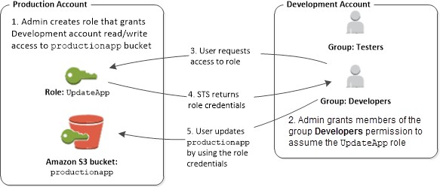

## STS with MFA

* Use GetSessionToken from STS

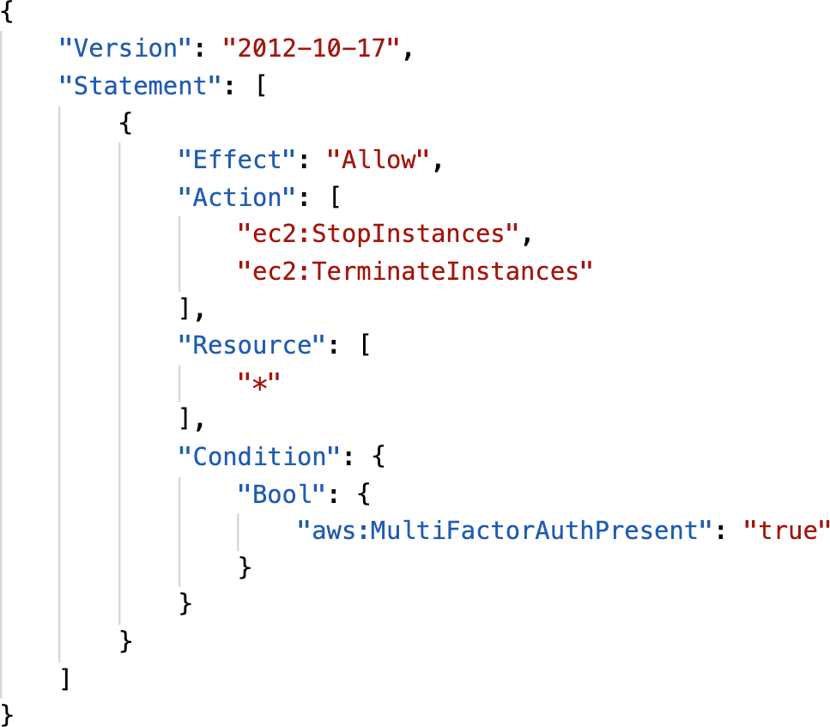

* Appropriate IAM policy using IAM Conditions
* aws:MultiFactorAuthPresent:true
* Reminder, GetSessionToken returns:
  + Access ID
  + Secret Key
  + Session Token
  + Expiration date

## IAM Best Practices – General

* Never use Root Credentials, enable MFA for Root Account
* Grant Least Privilege
  + Each Group / User / Role should only have the minimum level of permission it needs
  + Never grant a policy with “*” access to a service
  + Monitor API calls made by a user in CloudTrail (especially Denied ones)
* Never ever ever store IAM key credentials on any machine but a personal computer or on-premise server
* On premise server best practice is to call STS to obtain temporary security credentials

## IAM Best Practices – IAM Roles

* EC2 machines should have their own roles
* Lambda functions should have their own roles
* ECS Tasks should have their own roles (ECS_ENABLE_TASK_IAM_ROLE=true)
* CodeBuild should have its own service role
* Create a least-privileged role for any service that requires it
* Create a role per application / lambda function (do not reuse roles)

## IAM Best Practices – Cross Account Access

* Define an IAM Role for another account to access
* Define which accounts can access this IAM Role
* Use AWS STS (Security Token Service) to retrieve credentials and impersonate the IAM Role you have access to (AssumeRole API)
* Temporary credentials can be valid between 15 minutes to 1 hour



**user**



**Role (same or other account)**

**AssumeRole** API



**temporary security credential**



**AWS STS**



**permissions**

**IAM**



## Advanced IAM - Authorization Model Evaluation of Policies, simplified

1. If there’s an explicit DENY, end decision and DENY
2. If there’s an ALLOW, end decision with ALLOW
3. Else DENY

Decision starts at DENY

Explicit Deny?

No

Allow?

No

Yes

Yes

Final decision = “allow”

Final decision = “deny”

Final decision = “deny”

Evaluate all applicable Policies

## IAM Policies & S3 Bucket Policies

* IAM Policies are attached to users, roles, groups
* S3 Bucket Policies are attached to buckets
* When evaluating if an IAM Principal can perform an operation X on a bucket, the union of its assigned IAM Policies and S3 Bucket Policies will be evaluated.

Total Policy Evaluated

S3 Bucket Policy

IAM Policy

## Example 1

* IAM Role attached to EC2 instance, authorizes RW to “my_bucket”
* No S3 Bucket Policy attached

• => EC2 instance can read and write to “my_bucket”

## Example 2

* IAM Role attached to EC2 instance, authorizes RW to “my_bucket”
* S3 Bucket Policy attached, explicit deny to the IAM Role

• => EC2 instance cannot read and write to “my_bucket”

## Example 3

* IAM Role attached to EC2 instance, no S3 bucket permissions
* S3 Bucket Policy attached, explicit RW allow to the IAM Role

• => EC2 instance can read and write to “my_bucket”

## Example 4

* IAM Role attached to EC2 instance, explicit deny S3 bucket permissions
* S3 Bucket Policy attached, explicit RW allow to the IAM Role

• => EC2 instance cannot read and write to “my_bucket”

## Dynamic Policies with IAM

* How do you assign each user a /home/<user> folder in an S3 bucket?
* Option 1:
  + Create an IAM policy allowing georges to have access to /home/georges
  + Create an IAM policy allowing sarah to have access to /home/sarah
  + Create an IAM policy allowing matt to have access to /home/matt
  + … One policy per user!
  + This doesn’t scale
* Option 2:
  + Create one dynamic policy with IAM
  + Leverage the special policy variable ${aws:username}

Dynamic Policy example

©

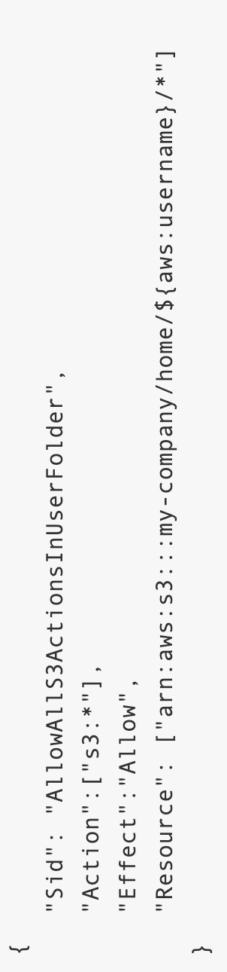

## Inline vs Managed Policies

* AWS Managed Policy
  + Maintained by AWS
  + Good for power users and administrators
  + Updated in case of new services / new APIs
* Customer Managed Policy
  + Best Practice, re-usable, can be applied to many principals
  + Version Controlled + rollback, central change management
* Inline
  + Strict one-to-one relationship between policy and principal
  + Policy is deleted if you delete the IAM principal

## Granting a User Permissions to Pass a Role to an AWS Service

* To configure many AWS services, you must pass an IAM role to the service (this happens only once during setup)
* The service will later assume the role and perform actions
* Example of passing a role:
  + To an EC2 instance
  + To a Lambda function
  + To an ECS task
  + To CodePipeline to allow it to invoke other services
* For this, you need the IAM permission iam:PassRole
* It often comes with iam:GetRole to view the role being passed

IAM PassRole example

© Stephane Maarek

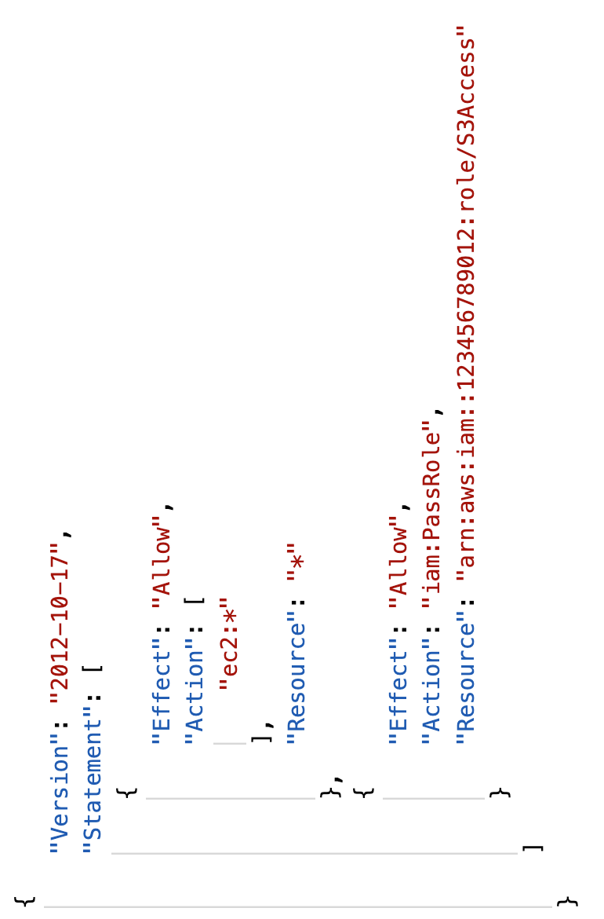

## Can a role be passed to any service?

* + No: Roles can only be passed to what their trust allows
  + A *trust policy* for the role that allows the service to assume the role

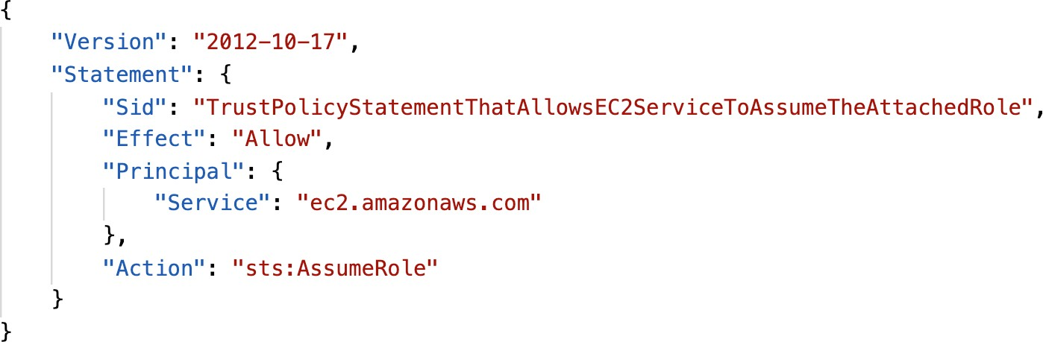

## What is Microsoft Active Directory (AD)?

* + Found on any Windows Server

with AD Domain Services

* + Database of objects: User Accounts, Computers, Printers, File Shares, Security Groups
  + Centralized security management, create account, assign permissions
  + Objects are organized in trees
  + A group of trees is a forest

John Password



Domain Controller

## AWS Directory Services

##### AWS Managed Microsoft AD

* + - Create your own AD in AWS, manage users locally, supports MFA
    - Establish “trust” connections with your on-

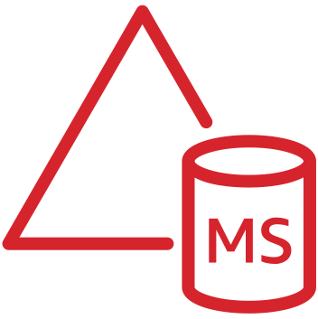

auth

trust

auth

premise AD

[www.datacumulus.com](http://www.datacumulus.com/)

##### AD Connector

* + - Directory Gateway (proxy) to redirect to on- premise AD, supports MFA
    - Users are managed on the on-premise AD

##### Simple AD

* + - AD-compatible managed directory on AWS
    - Cannot be joined with on-premise AD

On-prem AD AWS Managed AD



proxy

auth

On-prem AD AD Connector

# AWS Security & Encryption

KMS, Encryption SDK, SSM Parameter Store

Why encryption?

aGVsbG8gd29 ybGQgZWh…

U: admin

P: supersecret

### Encryption in flight (SSL)

* + Data is encrypted before sending and decrypted after receiving
  + SSL certificates help with encryption (HTTPS)
  + Encryption in flight ensures no MITM (man in the middle attack) can happen

HTTPS

aGVsbG8gd29 ybGQgZWh…

HTTPS Website (AWS)

You

U: admin

P: supersecret

aGVsbG8gd29 ybGQgZWh…

SSL Encryption SSL Decryption

## Why encryption?

### Server side encryption at rest

* + Data is encrypted after being received by the server
  + Data is decrypted before being sent
  + It is stored in an encrypted form thanks to a key (usually a data key)
  + The encryption / decryption keys must be managed somewhere and

the server must have access to it

Object

**Data key**

**Data key**

decryption

encryption

+

HTTP/S

HTTP/S

**AWS Service (ex: EBS)**

Object



## Why encryption?

### Client side encryption

* + Data is encrypted by the client and never decrypted by the server
  + Data will be decrypted by a receiving client
  + The server should not be able to decrypt the data
  + Could leverage Envelope Encryption

Any store (FTP,

**Client Encryption**

Object

Client Decryption

Object

S3, etc..)



encryption

+



+

decryption



Client side data key

Client side data key

## AWS KMS (Key Management Service)

* + Anytime you hear “encryption” for an AWS service, it’s most likely KMS
  + AWS manages encryption keys for us
  + Fully integrated with IAM for authorization
  + Easy way to control access to your data
  + Able to audit KMS Key usage using CloudTrail
  + Seamlessly integrated into most AWS services (EBS, S3, RDS, SSM…)

#### Never ever store your secrets in plaintext, especially in your code!

* + - KMS Key Encryption also available through API calls (SDK, CLI)
    - Encrypted secrets can be stored in the code / environment variables